***A Project Report on***

**PLANETARY ROVER WITH MOBILE MANIPULATOR USING ROS**

**A Dissertation Submitted in partial fulfilment of the requirements for the award of the degree of**

**BACHELOR OF TECHNOLOGY**

**In**

**COMPUTER SCIENCE ENGINEERING**

By

**GURVEER SINGH VIRK 21BD1A050F**

**MANTHAN VIJAYWARGIA 21BD1A050Y**

**NAYAN PANDRAMISHI 21BD1A051C**

**PREET SARDA 21BD1A051G**

**SRIKAR PROTHAPRAGADA 21BD1A051R**

**Under the esteemed guidance of**

**Mr. K. SAIKRISHNA**



**Department of Computer Science Engineering**

## KESHAV MEMORIAL INSTITUTE OF TECHNOLOGY

## AN AUTONOMOUS INSTITUTION - ACCREDITED BY NAAC WITH 'A' GRADE

**NARAYANAGUDA, HYDERABAD, TELANGANA-500029 2022-2023**

**TABLE OF CONTENTS**

**INDEX**

**ABSTRACT 4**

**CHAPTER 1 INTRODUCTION 5**

1.1 PROBLEM STATEMENT

1.2 OBJECTIVES

1.3 SCOPE

**CHAPTER 2 LITERATURE REVIEW 6**

**CHAPTER 3** **HARDWARE COMPONENTS 7**

3.1 PIXHAWK 2.4.8 7

3.2 SABERTOOTH 2X32 8

3.3 6 WHEEL DRIVE CHASSIS 9

3.4 APM POWER MODULE 10

3.5 BLDC MOTORS 11

3.6 TELEMETRY 12

3.7 JETSON NANO 13

3.8 PCA9685 16-CHANNEL PWM DRIVER 14

3.9 UBEC 15

3.10 6 DOF ROBOTIC ARM 16

3.11 MG995 SERVO MOTOR 17

3.12 RPLIDAR A1M8 18

3.13 USB TO UART BRIDGE 19

3.14 RASPBERRY PI CAMERA MODULE V2 20

3.15 GPS M8N 21

3.16 LI-ION BATTERY 22

**CHAPTER 4** **SOFTWARE COMPONENTS 24**

4.1 MISSION PLANNER – GCS 24

4.2 DRONEKIT 25

4.3 BLENDER 26

4.4 JETSON NANO DEVELOPER KIT IMAGE 29

4.5 UBUNTU 18.04 29

4.6 ROS MELODIC 30

4.7 MAVLINK 32

4.8 MAVROS 33

4.9 MAVPROXY 34

4.10 TELE OP KEYBOARD 35

4.11 MOVEIT 36

4.12 RVIZ 37

4.13 PCA9685 ROS NODE 38

4.14 SLAMTEC RPLIDAR ROS NODE 39

4.15 MOVE BASE 40

4.16 TF 41

4.17 CARTOGRAPHER 42

4.18 GSTREAMER 52

4.19 JETSON INFERENCE 53

4.20 XRDP 54

4.21 WEBSOCKET 55

4.21 FOXGLOVE56

**CONNECTION DIAGRAM**

**CHAPTER 5 ROVER CONTROL 57**

**CHAPTER 6 ROBOTIC ARM CONTROL 59**

**CHAPTER 7 COMPUTER VISION 63**

**CHAPTER 8 ROS NODES AND TOPICS 64**

**CONCLUSION 67**

**FUTURE ENHANCEMENTS 68**

**REFERENCES 70**

**APPENDIX 72**

**ABSTRACT**

This documentation presents a comprehensive overview of the development and implementation of a prototype planetary rover with a robotic arm using the Robot Operating System (ROS). The primary objective of this project is to tackle the challenges associated with object manipulation in a planetary environment by seamlessly integrating a robotic arm with a mobile rover platform.

The project leverages the capabilities of ROS as a powerful framework for communication, control, and coordination among the various components of the system. ROS provides a standardized and modular approach to software development, enabling efficient integration and seamless interaction between the rover, robotic arm, and other peripherals.

The documentation covers a wide range of aspects related to the project. It starts by outlining the objectives, clearly defining what the project aims to achieve within its scope. The scope of the project encompasses the development and implementation of the prototype rover with the robotic arm, emphasizing its potential for object manipulation in a planetary environment.

The system design section provides an in-depth description of the hardware and software components used in the project. It discusses the selection and integration of components such as the chassis, robotic arm, sensors, Nvidia Jetson Nano, and various software packages required for the project's functionality.

The methodology section details the steps followed during the development and implementation of the system. It includes the installation and configuration of ROS, implementation of SLAM algorithms, integration of the robotic arm, and object recognition and manipulation techniques.

The experimental setup section highlights the physical setup and connections between different hardware components. It illustrates how the robotic arm is mounted on the rover chassis, ensuring secure attachment and proper alignment. The software setup section explains the configuration and interaction of various software modules, highlighting the role of ROS in facilitating communication and control.

The documentation also presents the results and discusses the findings obtained during the project's execution. It evaluates the performance of the prototype rover with the robotic arm, highlighting its object manipulation capabilities, autonomous navigation, and overall system integration.

Finally, the documentation concludes by discussing potential future enhancements and improvements that could be implemented to enhance the functionality and performance of the system. These enhancements may include refining the algorithms, upgrading hardware components, or exploring advanced object recognition and manipulation techniques.

Overall, this documentation provides a comprehensive and detailed account of the development and implementation of a prototype planetary rover with a robotic arm using ROS. It serves as a valuable resource for understanding the project's objectives, scope, system design, methodology, experimental setup, results, and future possibilities for further development and enhancement.

**CHAPTER 1: INTRODUCTION**

**Problem Statement:**

To develop a planetary rover with a robotic arm using ROS to address the challenges of object manipulation in a planetary environment.

**Objectives:**

The main objectives of the project are as follows:

1. Provide a proof of concept for a planetary rover with a robotic arm system.
2. Design and integrate hardware components, including the robotic arm, chassis, sensors, and Nvidia Jetson Nano.
3. Develop computer vision algorithms for object detection and estimation of object poses.
4. Implement SLAM algorithms for autonomous navigation of the rover.
5. Leverage ROS for seamless integration and control of the system.
6. Test and evaluate the functionalities of the rover, including object manipulation and autonomous navigation.

The project focuses on developing a planetary rover with a robotic arm using ROS. The system aims to address the problem of performing object pick and drop operations autonomously in a simulated planetary environment. The project's objectives include designing and integrating hardware components, developing computer vision algorithms, implementing SLAM algorithms, leveraging ROS for system integration and control, testing the rover's functionalities, and documenting the project. By achieving these objectives, the project serves as a proof of concept for future advancements in robotic systems for planetary exploration.

**CHAPTER 2: LITERATURE REVIEW**

The use of robotic arms on planetary rovers has been a significant technology in space exploration for several decades. One notable example is the Sojourner arm, which was deployed on the Mars Pathfinder rover in 1997. The Sojourner arm played a crucial role in collecting samples of Martian soil and rocks, as well as deploying other scientific instruments on the rover.

Over time, robotic arms on planetary rovers have become increasingly sophisticated and capable. For instance, the Curiosity rover, which landed on Mars in 2012, features a robotic arm with seven degrees of freedom. This advanced arm enables Curiosity to reach and manipulate objects located far away from the rover, as well as perform intricate tasks such as drilling into rocks.

Robotic arms on planetary rovers serve various purposes, including:

* Collecting samples of soil and rocks for analysis.
* Deploying and operating scientific instruments.
* Repairing or replacing damaged components on the rover.
* Assisting in the deployment of other robotic systems.

Developing robotic arms for planetary rovers poses numerous challenges. The arms need to be lightweight and compact while still possessing the strength and durability to withstand the harsh conditions of space travel and the Martian environment. Additionally, they must operate reliably in extreme temperatures, dusty conditions, and high radiation levels.

Despite the challenges, the development of robotic arms for planetary rovers has been a resounding success. These arms have facilitated the collection of invaluable data about Mars and other celestial bodies, paving the way for future robotic exploration missions.

In terms of recent research, here are some notable papers on robotic arms for planetary rovers:

1. "A Review of Spatial Robotic Arm Trajectory Planning" by Xia et al. (2021).
2. "Robotic arm control system for mars rover analogue" by Wojewoda et al. (2020).
3. "Design of Rover and Robotic Arm" by Jotheess et al. (2020).

These research papers provide insights into trajectory planning, control systems, and design considerations for robotic arms on planetary rovers.

**Chapter 3: HARDWARE COMPONENTS**

The hardware components of the planetary rover with a robotic arm system play a crucial role in its overall functionality and performance. The following are the key hardware components used in the robotic system.

**Rover:**

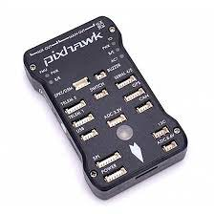**3.1 PIXHAWK 2.4.8**

Pixhawk is an open-source hardware and software platform designed for autonomous vehicles, specifically unmanned aerial vehicles (UAVs) or drones. It is widely used in the field of robotics and aerial robotics due to its reliability and versatility. The Pixhawk platform provides a high-performance autopilot system that can control the flight of a UAV, manage sensors and peripherals, and execute autonomous missions.

Key features of Pixhawk include:

**Autopilot Hardware**: Pixhawk consists of a flight controller board that serves as the autopilot system. It incorporates a microcontroller unit (MCU) along with various sensors such as accelerometers, gyroscopes, magnetometers, barometers, and GPS receivers. These sensors provide crucial data for stabilizing and controlling the vehicle.

**Sensor Integration:** Pixhawk supports integration with a wide range of sensors, including Lidar, sonar, optical flow sensors, and more. This allows for precise navigation and obstacle avoidance capabilities.

**Flight Control Software:** Pixhawk runs an open-source firmware called ArduPilot, which provides the flight control algorithms and software stack for autonomous flight. ArduPilot is a highly capable and widely adopted open-source autopilot software, supporting a vast array of features such as GPS waypoint navigation, altitude hold, automatic take-off and landing, and advanced flight modes.

**Mission Planning and Control:** Pixhawk can be programmed to execute complex missions autonomously. Using ground control station (GCS) software such as Mission Planner or QGroundControl, users can plan flight routes, set waypoints, define actions, and monitor real-time telemetry data from the UAV during the mission.

**Connectivity and Compatibility**: Pixhawk supports various communication protocols, including UART, I2C, SPI, and CAN, allowing integration with a wide range of peripherals and accessories. It is also compatible with different radio control systems and telemetry modules for remote control and telemetry data transmission.

Pixhawk has gained popularity due to its open-source nature, allowing for community collaboration, customization, and continuous improvement. It has been widely adopted in both professional and hobbyist UAV applications, enabling autonomous flight, aerial mapping, precision agriculture, search and rescue missions, and more.

**3.2 SABERTOOTH 2x32**

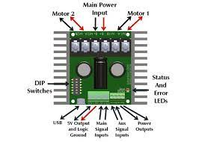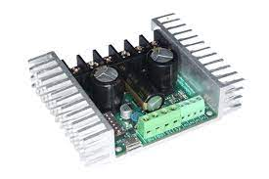

The Sabertooth 2x32 is a specific model of motor driver from Dimension Engineering's Sabertooth series. It is designed to control two brushed DC motors simultaneously, offering high power and versatility for various applications.

Here are some key features and specifications of the Sabertooth 2x32:

**Motor Control:** The Sabertooth 2x32 can control two brushed DC motors independently, providing bidirectional control (forward and reverse) and variable speed control for each motor.

**High Power Handling:** It is capable of handling high currents and voltages, allowing it to drive motors with substantial power requirements. The Sabertooth 2x32 can handle peak currents of up to 64 amps per channel and continuous currents of up to 32 amps per channel.

**Dual Channel Configuration:** This motor driver has two motor channels, which means it can control two separate motors independently. This feature is beneficial for applications that require differential steering or the control of multiple motors.

**Multiple Control Modes:** The Sabertooth 2x32 offers multiple control modes, including simplified serial mode, analog mode, and radio control (RC) mode. These modes allow users to choose the control method that best suits their application and interface with the motor driver accordingly.

**Built-in Protection Features**: The Sabertooth 2x32 incorporates built-in protection mechanisms to safeguard the motors and the driver itself. These protection features may include thermal protection, overcurrent protection, overvoltage protection, and stall detection, among others.

**Communication Interfaces:** The Sabertooth 2x32 supports different communication interfaces, such as serial (RS232 or TTL) and analog control signals. This enables easy integration with microcontrollers, computers, or other devices for motor control.

**Battery Elimination Circuit (BEC):** Functionality: The Sabertooth 2x32 has a built-in Battery Elimination Circuit (BEC) that can power the connected microcontroller or control system using the same battery used to power the motors. This simplifies the power supply setup and reduces the need for additional power sources.

**Dimensions and Form Factor:** The Sabertooth 2x32 has compact dimensions and is designed to be easily mounted on robotic platforms or integrated into other projects. It has mounting holes for secure attachment and measures approximately 3.2 x 3.2 x 1.2 inches (81 x 81 x 30 mm).

The Sabertooth 2x32 is commonly used in applications that require precise control and high power handling, such as robotics, automation, electric vehicles, and other projects with demanding motor control requirements. Its robust construction, built-in protection features, and support for various control interfaces make it a popular choice among hobbyists, researchers, and professionals in the field.

**3.3 6 WHEEL DRIVE CHASSIS**

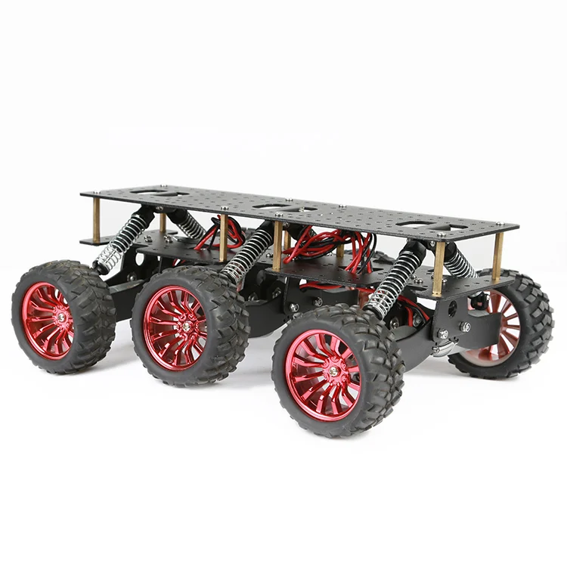

A 6WD (6-Wheel Drive) chassis refers to a robotic or vehicle platform equipped with six wheels, each driven independently. This configuration offers increased traction, stability, and manoeuvrability compared to traditional 4WD or 2WD setups. Here are some key aspects of a 6WD chassis:

**Wheel Configuration:** A 6WD chassis typically consists of six wheels distributed across the length of the chassis. The wheels are evenly spaced and may be arranged in a variety of configurations, such as three pairs of wheels or two pairs of wheels with an additional centre wheel for improved stability.

**Independent Wheel Drive:** Each wheel in a 6WD chassis has its own motor and drive mechanism, allowing for individual control of wheel speed and direction. This independent drive system provides enhanced manoeuvrability and the ability to execute complex movements, such as omni-directional or differential steering.

**Traction and Load Distribution**: With six wheels, a 6WD chassis offers increased traction and load-carrying capacity compared to vehicles with fewer wheels. The weight of the chassis and payload can be distributed more evenly, reducing the risk of wheel slippage and improving overall stability on various terrains.

**Suspension and Shock Absorption:** To enhance the cassis’s performance over rough terrain, 6WD systems may incorporate suspension systems or shock absorbers. These features help absorb impacts and maintain stability while traversing uneven surfaces, ensuring better wheel contact and minimizing vibrations.

**Control and Motor Coordination:** The control system of a 6WD chassis should be designed to handle the independent control of each wheel. This may involve a combination of motor controllers, microcontrollers, and sensors to enable coordinated movement and efficient control of the vehicle.

**Applications:** 6WD chassis are commonly used in various applications that require enhanced mobility and off-road capabilities. Some examples include robotics, unmanned ground vehicles (UGVs), exploration rovers, agricultural machinery, search and rescue vehicles, and military vehicles.

When implementing a 6WD chassis, it is essential to consider factors such as motor selection, power distribution, control system design, and chassis construction. Proper weight distribution, appropriate wheel and tire selection, and robust mechanical design are also crucial for optimal performance and durability.

Overall, a 6WD chassis provides enhanced traction, stability, and manoeuvrability, making it suitable for demanding applications where traversing challenging terrains or carrying heavy loads is required.

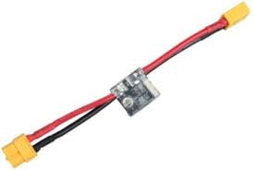**3.4 APM POWER MODULE**

The APM Power Module is a component used in autonomous vehicles and drones, specifically designed for the ArduPilot Mega (APM) flight controller. It serves as a power supply module and voltage/current sensor, providing accurate power measurements and voltage regulation for the flight controller and other connected electronic devices.

Here are some key features and functions of the APM Power Module:

**Power Supply:** The APM Power Module is responsible for supplying power to the APM flight controller and other onboard electronic components. It typically connects to the vehicle's main power source, such as a battery or power distribution board.

**Voltage Regulation:** The power module includes a voltage regulator circuit that ensures a stable and regulated voltage output to the flight controller and other devices. This helps prevent voltage fluctuations and protects sensitive electronics from damage.

**Current Sensing:** The APM Power Module features a current sensor that measures the current flowing through the system. This information is used to monitor power consumption and calculate battery capacity or remaining flight time.

**Power Monitoring:** The power module provides real-time power monitoring capabilities, allowing the flight controller to display and log voltage and current data. This information is essential for assessing the status of the power system and optimizing flight performance.

**Safety and Protection:** The APM Power Module incorporates safety features to protect the system from overcurrent, overvoltage, and overtemperature conditions. These protection mechanisms help prevent damage to the power module and connected devices.

**Telemetry Integration:** The power module often includes telemetry interfaces, such as an I2C or serial connection, to transmit power-related data to the ground control station. This allows for real-time monitoring of power parameters during flight.

**Compatibility:** The APM Power Module is specifically designed for use with the ArduPilot Mega (APM) flight controller, which is an open-source autopilot system widely used in autonomous vehicles and drones. It is compatible with various APM-based flight controller boards and can be easily integrated into APM-based systems.

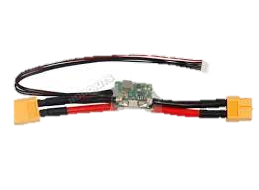The APM Power Module is an essential component for power management and monitoring in APM-based autonomous vehicles and drones. It provides stable power supply, accurate current sensing, and power monitoring capabilities, ensuring reliable and safe operation of the onboard electronics.

**3.5 BLDC MOTORS**

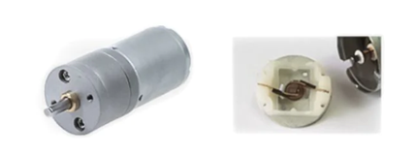

BLDC stands for Brushless DC motors, which are electric motors that use electronic commutation instead of brushes and a commutator found in brushed DC motors. BLDC motors offer several advantages over traditional brushed DC motors, including higher efficiency, longer lifespan, and better speed control.

These motors operate at 12V and have the following specifications:

* Operating voltage: 12V
* Maximum load: 6kg
* Rated Current: 350mA * 6
* Motor original speed: 17000 rpm
* Output shaft speed: 500 rpm
* Nominal torque: 5 kg / cm

BLDC motors are a type of electric motor that utilize permanent magnets and electronically controlled commutation to generate motion. They offer several advantages over traditional brushed motors, including higher efficiency, longer lifespan, and reduced maintenance requirements.

Operating at a voltage of 12V, these BLDC motors are designed to provide reliable and efficient propulsion for the rover. The maximum load rating of 6kg indicates the maximum weight the motors can effectively drive. This specification is crucial for ensuring that the motors can handle the weight of the rover and any additional payload.

The rated current of 350mA * 6 indicates the current consumption of each motor. This specification helps determine the power requirements and ensures that the power supply can adequately provide the necessary current to drive the motors.

The motor's original speed of 17000 rpm refers to the unloaded speed at maximum voltage. However, for the rover's operation, the output shaft speed is reduced to 500 rpm. This reduction in speed allows for better control, torque, and manoeuvrability of the rover, ensuring smooth and precise movements in different terrains.

The nominal torque of 5 kg/cm indicates the force exerted by the motor to overcome resistance and drive the rover's wheels. This torque specification is crucial for assessing the motor's ability to handle different terrain conditions and drive the rover effectively, even in challenging environments.

These BLDC motors have been selected based on their specifications to ensure they meet the requirements of the rover's propulsion system. The combination of their operating voltage, maximum load capacity, rated current, speed characteristics, and nominal torque makes them suitable for providing reliable and efficient mobility to the rover, allowing it to navigate various terrains encountered during its operation.

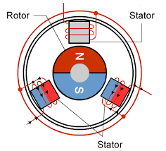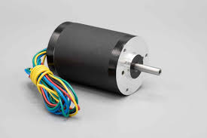

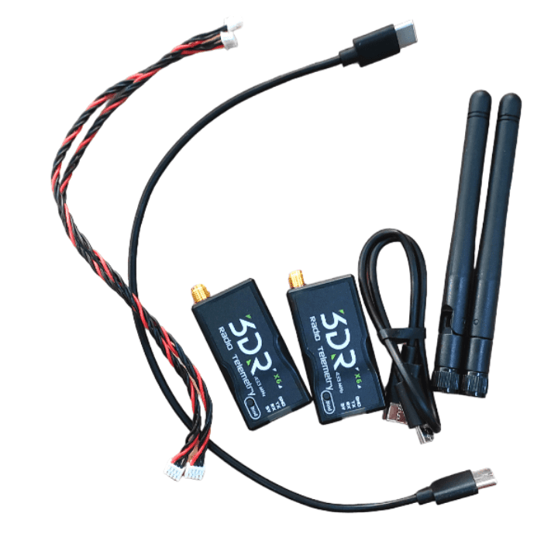**3.6 TELEMETRY**

Telemetry refers to the transmission and reception of real-time data wirelessly from remote or inaccessible locations. In the context of electronics and technology, telemetry is commonly used to monitor and transmit data from sensors, devices, or systems to a central control station or monitoring system.

Here are some key points about telemetry:

* **Data Transmission:** Telemetry involves the wireless transmission of data, typically in real-time or near real-time, from a remote location to a central monitoring system. The data can be in various forms, such as sensor readings, measurements, status updates, diagnostic information, or control signals.
* **Wireless Communication:** Telemetry systems utilize wireless communication technologies to transmit data over a certain distance. This can include technologies like Wi-Fi, Bluetooth, cellular networks (2G, 3G, 4G, or 5G), satellite communication, or specialized telemetry protocols.
* **Remote Monitoring and Control:** Telemetry allows for remote monitoring and control of devices or systems that are located at a distance, in hazardous environments, or in areas difficult to access. It enables real-time data collection, analysis, and decision-making without the need for physical presence.
* **Applications:** Telemetry is used in various industries and applications, including:
  + Environmental Monitoring: Collecting data on weather conditions, air quality, water quality, and other environmental parameters.
  + Industrial Automation: Monitoring and controlling industrial processes, equipment, and machinery.
  + Healthcare: Remote patient monitoring, medical device telemetry, and telemedicine applications.
  + Aerospace and Defense: Monitoring aircraft, satellites, or unmanned aerial vehicles (UAVs) for performance, diagnostics, and control.

Telemetry plays a vital role in enabling real-time monitoring, control, and data collection from remote locations or inaccessible environments. It provides valuable insights, enhances efficiency, and facilitates informed decision-making in a wide range of industries and applications.

**ROBOTIC ARM**

**3.7 JETSON NANO**

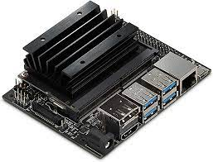

The Jetson Nano is a small, powerful, and energy-efficient single-board computer (SBC) developed by NVIDIA. It is specifically designed for AI (Artificial Intelligence) and edge computing applications. The Jetson Nano is part of the Jetson family of embedded systems, which includes other models like the Jetson Xavier and Jetson TX2.

Here are some key features and information about the Jetson Nano:

**GPU Acceleration:** The Jetson Nano features an integrated NVIDIA GPU (Graphics Processing Unit) based on the Maxwell architecture. This GPU provides hardware acceleration for AI tasks, making it capable of running deep neural networks and machine learning algorithms with high performance.

**AI Performance:** With its GPU and dedicated AI hardware, the Jetson Nano delivers significant AI computing power. It can perform tasks such as image recognition, object detection, speech processing, and more, making it suitable for a wide range of AI applications.

**CPU and Memory:** The Jetson Nano is equipped with a quad-core ARM Cortex-A57 CPU running at 1.43 GHz. It also has 4 GB of LPDDR4 RAM, which provides sufficient processing power and memory for AI workloads.

**Connectivity and I/O:** The Jetson Nano offers various connectivity options, including Gigabit Ethernet, USB 3.0, USB 2.0, HDMI, and a 40-pin GPIO header for connecting to external devices and peripherals. It also has an onboard Wi-Fi and Bluetooth module for wireless communication.

**Software Support:** The Jetson Nano is supported by NVIDIA's JetPack software development kit (SDK), which includes libraries, APIs, and tools for developing and deploying AI applications. It is compatible with popular AI frameworks like TensorFlow, PyTorch, and Caffe, allowing developers to leverage their existing knowledge and code.

**Power Efficiency:** The Jetson Nano is designed to be power-efficient, making it suitable for embedded and edge computing applications where power consumption is a concern. It can be powered using a standard 5V/2A micro-USB power supply.

The Jetson Nano has gained popularity among developers, hobbyists, and researchers who want to build and deploy AI applications at the edge. It enables the development of smart cameras, drones, robots, IoT devices, and other AI-powered systems with advanced capabilities.

**3.8 PCA9685 16-CHANNEL PWM DRIVER**

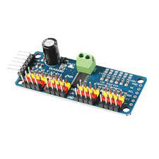

The PCA9685 is a popular 16-channel servo controller integrated circuit (IC) developed by NXP Semiconductors. While it is primarily designed for controlling servo motors, it can also be used as a motor driver for other types of motors, such as DC motors or stepper motors. Here's some key information about the PCA9685 motor driver:

**Control of Multiple Motors:** The PCA9685 can control up to 16 individual motors or other PWM-controlled devices. It provides 12-bit resolution for each channel, allowing for precise control of motor speed or position.

**Pulse Width Modulation (PWM):** The PCA9685 utilizes PWM signals to control the motors. PWM is a technique where the width of a pulse determines the position, speed, or intensity of the motor. By varying the pulse width, the PCA9685 can set the desired position, speed, or intensity for each motor connected to its channels.

**I2C Interface:** The PCA9685 communicates with the microcontroller or host system using the I2C (Inter-Integrated Circuit) protocol. The I2C interface allows for easy integration with various microcontrollers and provides flexibility in controlling the motors.

**Onboard Oscillator:** The PCA9685 features an onboard oscillator that generates a clock signal for precise timing and synchronization of the PWM signals. This ensures accurate control of the motors and helps maintain consistent operation across all channels.

**Programmable Prescaler:** The PCA9685 includes a programmable prescaler that allows users to adjust the PWM frequency. By changing the prescaler value, the PWM frequency can be set to match the requirements of the motors being used.

**Cascading and Synchronization:** Multiple PCA9685 modules can be cascaded together to control even more motors or devices. By synchronizing the clock signals across multiple modules, it is possible to control a large number of motors simultaneously.

**Built-in LED Driver:** In addition to motor control, the PCA9685 has built-in LED drivers. This feature enables the control of LEDs or other lighting devices, making the PCA9685 a versatile controller for both motors and lighting applications.

**NOTE:** When using the PCA9685 as a motor driver, it's important to consider the specific motor type and requirements, as well as the power limitations of the PCA9685 itself. External power sources may be necessary to provide sufficient power for the motors.

Overall, the PCA9685 motor driver offers a convenient and flexible solution for controlling multiple motors or PWM-driven devices using the I2C interface. It is commonly used in robotics, animatronics, drones, RC (remote control) vehicles, and other projects that require precise and synchronized control of multiple motors.

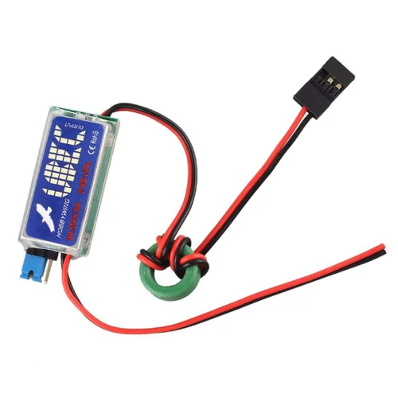**3.9 UBEC**

A UBEC (Universal Battery Elimination Circuit) is a voltage regulator commonly used in radio-controlled (RC) hobby applications. It serves as a power supply unit that converts a higher voltage input from a battery or power source to a lower and stable voltage suitable for powering electronic devices or servos.

Here's some key information about UBEC:

**Voltage Regulation:** A UBEC typically takes a higher input voltage, such as from a battery pack (e.g., 2S, 3S, 4S LiPo), and regulates it to a stable and lower output voltage, such as 5 volts or 6 volts. This regulated output voltage is often used to power RC receivers, flight controllers, servos, and other electronic components.

**Current Capacity:** UBECs are available in various current capacities, ranging from a few amperes to tens of amperes. The current capacity required depends on the power requirements of the RC system and the number of servos or devices being powered.

**Switching vs. Linear UBEC:** UBECs can be classified into two types: switching and linear. Switching UBECs are more efficient and generate less heat, making them suitable for applications where power efficiency is important. Linear UBECs are simpler and less expensive but tend to dissipate more power as heat. The choice between the two depends on the specific application and power requirements.

**Protection Features:** Many UBECs incorporate protection features to ensure safe operation. These may include overvoltage protection, overcurrent protection, and thermal shutdown. These protection mechanisms help prevent damage to the UBEC and connected devices in case of electrical faults or excessive power draw.

**Connection and Wiring:** UBECs typically have input and output terminals for connecting to the power source and the devices to be powered. The input side is connected to the battery or power source, while the output side is connected to the electronic components or servos.

UBECs play a vital role in RC applications by providing a stable and regulated power supply for electronic components, servos, and receivers. They eliminate the need for separate batteries, reduce weight, and simplify the power distribution system in RC vehicles and aircraft.

It's important to choose a UBEC with the appropriate voltage output and current capacity to match the requirements of your RC system and the devices you intend to power. Always follow the manufacturer's instructions and guidelines when installing and using a UBEC to ensure safe and reliable operation

**3.10 6 DOF ROBOTIC ARM**

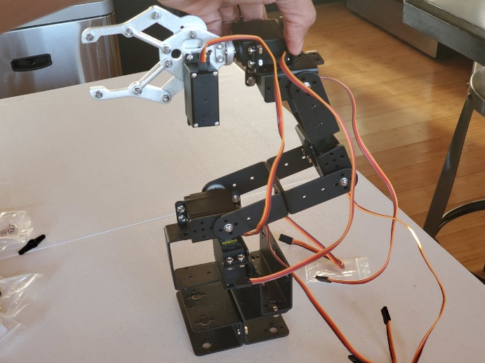

A 6-DOF robotic arm refers to a robotic arm that has six degrees of freedom. Each degree of freedom represents a specific movement or rotation that the robotic arm can perform.

Here's a breakdown of the six degrees of freedom in a typical 6-DOF robotic arm:

**Base Rotation:** The base of the robotic arm can rotate horizontally, allowing the arm to pivot around its base.

**Shoulder Rotation:** The shoulder joint enables the arm to move up and down vertically, similar to a human shoulder.

**Elbow Rotation:** The elbow joint allows the arm to bend and extend, providing flexibility in reaching different positions.

**Wrist Pitch:** The wrist joint enables the arm to tilt forward and backward, providing pitch movement.

**Wrist Roll:** The wrist can rotate around its own axis, allowing for rotational movement of the end effector.

**Gripper / End Effector:** The end of the arm is typically equipped with a gripper or specialized tool for grasping or manipulating objects.

These six degrees of freedom provide the robotic arm with the capability to reach and manipulate objects in a three-dimensional space. By combining these movements in various ways, the robotic arm can perform complex tasks such as pick-and-place operations, assembly, welding, and more.

In addition to the degrees of freedom, a 6-DOF robotic arm is controlled by a controller or computer system that receives commands and coordinates the movements of the arm's joints. This control system can be programmed to perform precise and repeatable motions, allowing the robotic arm to automate various industrial or research tasks.

The design and specifications of a 6-DOF robotic arm can vary depending on the specific application and requirements. There are commercially available robotic arms, as well as DIY options, that offer different sizes, payloads, and levels of precision to suit a wide range of applications in manufacturing, research, education, and more.

**3.11 MG995 SERVO MOTOR**

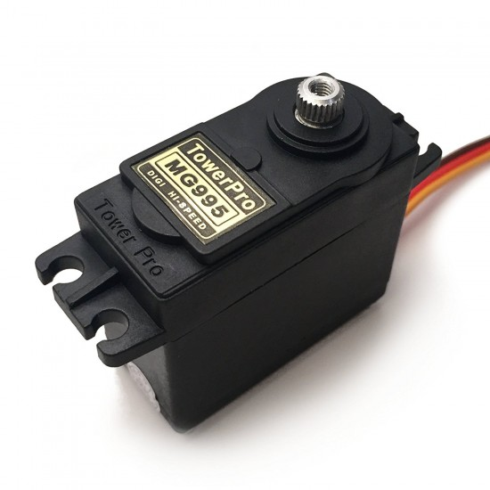

The MG995 servo is a popular and widely used standard-sized servo motor in hobbyist and robotics applications.

Here's some key information about the MG995 servo:

**Size and Specifications:** The MG995 servo is a standard-sized servo motor, also known as a standard servo or medium servo. It typically has dimensions of around 40mm x 20mm x 38mm and weighs approximately 55 grams. The servo motor operates on a voltage range of 4.8V to 7.2V.

**Torque and Speed**: The MG995 servo is known for its high torque output. It can deliver a maximum torque of around 9 kg/cm (or approximately 125 oz/in) at 6V. The rotational speed of the servo motor varies depending on the voltage applied, typically ranging from 0.17 seconds/60 degrees at 4.8V to 0.13 seconds/60 degrees at 6V.

**Control Signal:** The MG995 servo uses a standard PWM (Pulse Width Modulation) control signal for position control. By varying the pulse width of the control signal within a specific range (typically 1000μs to 2000μs), the servo motor can be controlled to move to different positions within its range of motion.

**Operating Angle:** The MG995 servo has an operating angle of approximately 180 degrees, which means it can rotate from 0 degrees to 180 degrees. The actual operating angle may vary slightly depending on the specific model and setup.

**Construction and Gear Train:** The MG995 servo features a durable plastic case and a metal gear train. The metal gears provide enhanced durability and strength, making the servo suitable for applications that require higher torque and load-bearing capabilities.

**Applications:** The MG995 servo is commonly used in various robotic applications, RC vehicles, aircraft, pan-tilt camera mounts, and other projects that require precise and controlled angular motion. Its high torque, relatively fast speed, and moderate cost make it a popular choice for hobbyists and robotics enthusiasts.

When using the MG995 servo, it's important to provide the appropriate power supply within the specified voltage range and ensure that the control signal is compatible with the servo motor's PWM requirements. Following the manufacturer's instructions and guidelines will help ensure optimal performance and longevity of the servo motor.

**SENSORS**

**3.12 RPLIDAR A1M8**

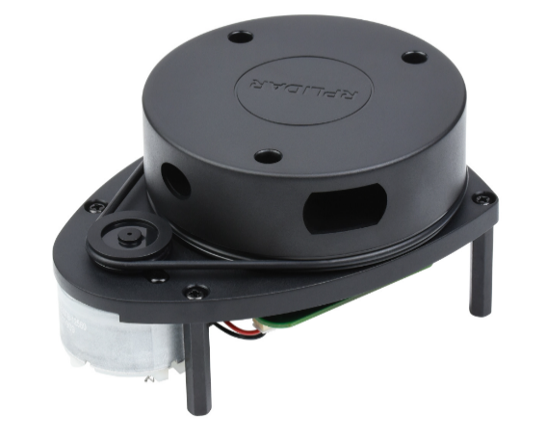

RP Lidar (also known as RPLidar) is a line of lidar (Light Detection and Ranging) sensors developed by RoboPeak. Lidar sensors use laser beams to measure distances and create a 360-degree map of the surrounding environment.

Here's some key information about RP Lidar:

**Sensor Technology:** RP Lidar sensors utilize time-of-flight (TOF) technology to measure the time it takes for laser pulses to bounce off objects and return to the sensor. This data is then processed to generate 2D or 3D point cloud representations of the surroundings.

**Range and Resolution:** RP Lidar sensors have different models with varying ranges and resolutions. The range typically varies from a few meters to tens of meters, depending on the specific model. The resolution refers to the level of detail or precision in capturing distance measurements and can vary from a few millimeters to a few centimeters.

**Field of View:** RP Lidar sensors offer a wide field of view, often spanning a full 360 degrees. This enables comprehensive environmental mapping and obstacle detection without blind spots.

**Connectivity and Compatibility:** RP Lidar sensors generally support common communication interfaces such as USB, UART, or I2C. This makes them compatible with a wide range of platforms, including embedded systems, microcontrollers, computers, and robots.

**Applications:** RP Lidar sensors find applications in various fields, including robotics, autonomous vehicles, mapping and surveying, environmental monitoring, and more. They are often used for localization, navigation, object detection, and mapping tasks in indoor and outdoor environments.

**Software Support:** RP Lidar sensors come with software development kits (SDKs) and libraries that provide APIs and tools for integrating the sensors into different platforms and programming languages. These SDKs offer functionalities such as data visualization, sensor calibration, and data processing.

**Cost and Accessibility:** RP Lidar sensors are known for their relatively affordable pricing compared to some high-end lidar sensors. This accessibility makes them popular among hobbyists, researchers, and developers working on robotics and autonomous systems projects.

**3.13 USB TO UART BRIDGE**

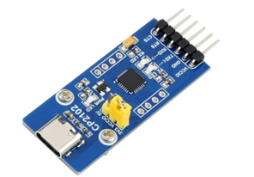

A USB to UART bridge, also known as a USB to serial converter, is a device that facilitates communication between a computer or USB-enabled device and a serial device using the Universal Asynchronous Receiver-Transmitter (UART) protocol.

Here's some key information about USB to UART bridges:

**Purpose:** The primary purpose of a USB to UART bridge is to enable communication between devices that use different communication standards. It allows a computer or USB-enabled device without built-in UART functionality to connect and communicate with serial devices such as microcontrollers, embedded systems, sensors, and other devices that use UART for serial communication.

**USB Interface:** USB to UART bridges connect to the computer or USB-enabled device via a USB interface. They usually have a USB Type-A connector on one end that plugs into the USB port of the computer or device.

**UART Interface:** On the other end, USB to UART bridges have a UART interface, typically in the form of pins or a connector, that connects to the serial device. The UART interface consists of transmit (TX), receive (RX), and optionally other control signals such as data terminal ready (DTR) and data carrier detect (DCD).

**Driver and Virtual COM Port:** To use a USB to UART bridge, the computer or USB-enabled device typically requires a driver. The driver allows the operating system to recognize the USB to UART bridge as a virtual COM port, allowing software applications to communicate with the connected serial device using standard serial communication protocols.

**Baud Rate and Configuration:** USB to UART bridges often support various baud rates and configuration options. The baud rate determines the rate at which data is transmitted and received between the computer and the serial device. Configuration options may include parity, data bits, and stop bits, allowing for customization of the serial communication parameters.

**Compatibility:** USB to UART bridges are compatible with different operating systems, including Windows, macOS, and Linux. They are widely used in various applications, including programming and debugging microcontrollers, interfacing with sensors and modules, and serial communication with embedded systems.

USB to UART bridges provide a convenient and reliable means of establishing serial communication between computers and USB-enabled devices and serial devices. They eliminate the need for legacy serial ports on modern computers and offer flexibility in connecting and interacting with a wide range of serial devices.

**3.14 RASPBERRY PI CAMERA V2**

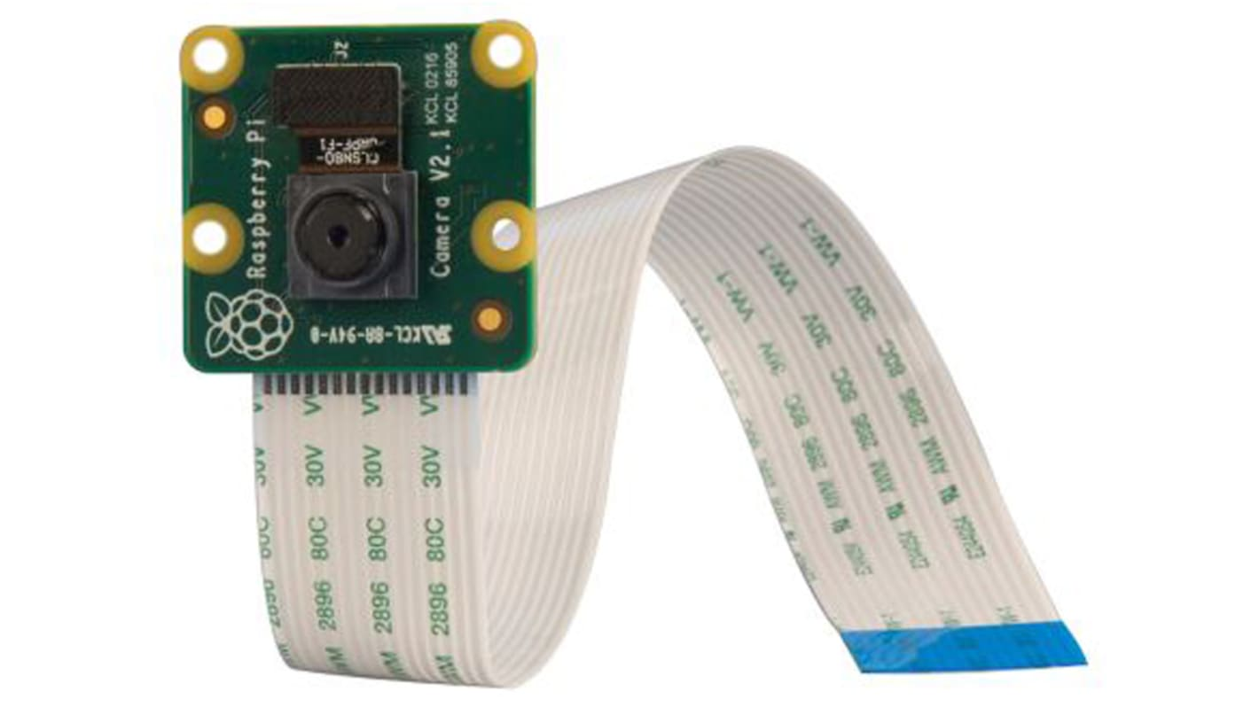

The Raspberry Pi Camera Module V2 is a camera peripheral designed specifically for use with Raspberry Pi boards. It offers various features and capabilities for capturing images and videos.

Key details include:

**Purpose:** The Raspberry Pi Camera Module V2 is used to capture high-quality images and videos directly from a Raspberry Pi board. It provides a convenient way to integrate imaging capabilities into projects, such as surveillance systems, robotics, computer vision, and more.

**Image Sensor:** The camera module features a Sony IMX219 8-megapixel image sensor. This sensor provides high-resolution images with good sensitivity and low noise levels. It supports various image formats and resolutions, allowing for versatile image capture.

**Lens:** The Raspberry Pi Camera Module V2 includes a fixed-focus lens. The lens has a focal length of 3.04mm and a wide-angle field of view, providing flexibility in capturing a broad scene.

**Resolution:** The camera module supports a maximum still image resolution of 3280 x 2464 pixels, which corresponds to 8-megapixel quality. It also supports various video resolutions, including Full HD (1080p) and HD (720p) at different frame rates.

**Interface:** The camera module connects directly to the CSI (Camera Serial Interface) port on the Raspberry Pi board. This CSI interface provides a dedicated high-speed data link between the camera module and the Raspberry Pi, enabling fast and efficient data transfer.

**Compatibility:** The Raspberry Pi Camera Module V2 is specifically designed for compatibility with Raspberry Pi boards. It is compatible with various models, including Raspberry Pi 4, Raspberry Pi 3, Raspberry Pi Zero, and others.

**Software Support:** The camera module is supported by the official Raspberry Pi Camera software, including the raspistill and raspivid commands, which provide a simple interface for capturing images and videos. It also works with popular software libraries and frameworks, such as OpenCV, enabling advanced image processing and computer vision applications.

The Raspberry Pi Camera Module V2 offers a cost-effective and versatile imaging solution for Raspberry Pi projects. With its high-resolution image sensor, flexible lens, and easy integration with Raspberry Pi boards, it provides the capability to capture images and videos for a wide range of applications.

**3.15 GPS M8N**

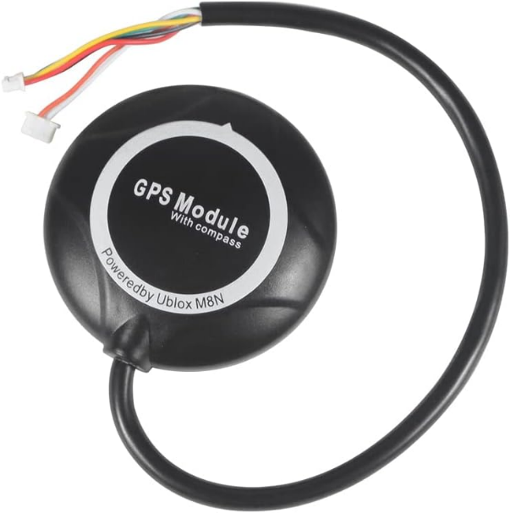

The GPS M8N module is a Global Positioning System (GPS) receiver that provides accurate positioning and navigation information. It offers various features and capabilities for determining precise location data.

Key details include:

**Purpose:** The GPS M8N module is used to obtain accurate geographical coordinates, altitude, and precise time information. It enables the rover to determine its position, navigate accurately, and perform tasks such as mapping, tracking, and waypoint navigation.

**Receiver Chip:** The GPS M8N module features the u-blox M8N receiver chip. This receiver chip utilizes advanced satellite navigation technology, including GPS, GLONASS, Galileo, and QZSS satellite systems, to provide reliable and accurate positioning data.

**Positioning Accuracy:** The GPS M8N module offers high positioning accuracy, typically within a few meters. With the support of multiple satellite systems, it improves accuracy, especially in challenging environments with obstructed or limited satellite visibility.

**Interface:** The GPS M8N module typically connects to the rover's main control unit or microcontroller using a UART (Universal Asynchronous Receiver-Transmitter) interface. This interface allows for serial communication and enables the retrieval of GPS data.

**Configuration and Control**: The GPS M8N module can be configured and controlled using the appropriate commands and protocols. It supports standard NMEA (National Marine Electronics Association) messages, allowing for easy integration with software applications and systems.

**Power Requirements:** The GPS M8N module operates at a voltage range compatible with the rover's power supply. It is designed to be power-efficient, consuming minimal power during operation.

**Compatibility:** The GPS M8N module is compatible with various platforms and systems, making it suitable for integration into different projects. It can be used with microcontrollers, single-board computers, and other devices that support serial communication.

**Software Support:** The GPS M8N module is supported by software libraries and frameworks that facilitate data retrieval, parsing, and processing of GPS information. These software tools enable developers to extract and utilize the GPS data for navigation, mapping, and other location-based applications.

The GPS M8N module provides reliable and accurate positioning and navigation capabilities for the rover. With its advanced receiver chip and support for multiple satellite systems, it offers high positioning accuracy and robust performance in various environments.

**3.16 Li-ION BATTERY**

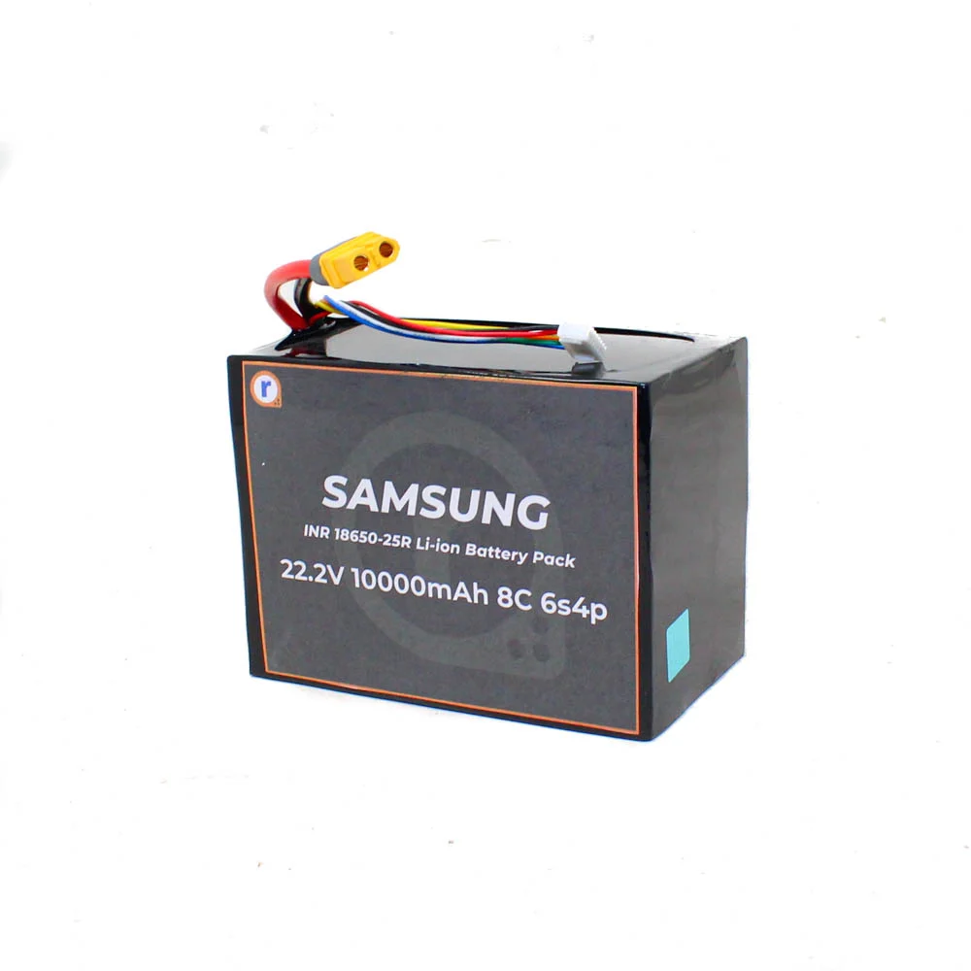

The Li-ion (Lithium-ion) battery is a type of rechargeable battery widely used in various electronic devices, including the components of the planetary rover project. Li-ion batteries offer several advantages over other battery chemistries, making them suitable for powering portable and mobile applications. Here is a detailed explanation of Li-ion batteries and their relevance to the project:

1. Battery Chemistry: Li-ion batteries use lithium ions as the primary charge carriers. They typically consist of one or more lithium-based compounds as the cathode, a carbon-based material as the anode, and an electrolyte that facilitates the movement of lithium ions between the electrodes during charging and discharging.

2. Energy Density: Li-ion batteries are known for their high energy density, which refers to the amount of energy stored per unit mass or volume of the battery. This high energy density allows Li-ion batteries to store a significant amount of energy in a compact and lightweight form, making them suitable for portable and mobile applications like the planetary rover.

3. Rechargeability: Li-ion batteries are rechargeable, meaning they can be charged and discharged multiple times without significant loss of capacity. This feature eliminates the need for frequent battery replacements and allows for efficient energy management in the rover system.

4. Voltage and Capacity: Li-ion batteries typically have a nominal voltage of 3.7 volts per cell. The capacity of a Li-ion battery is measured in ampere-hours (Ah) and represents the total amount of charge the battery can store. The specific voltage and capacity of the Li-ion battery used in the project would depend on the power requirements of the rover's components and the desired runtime.

5. Safety Considerations: While Li-ion batteries offer numerous benefits, they also require careful handling and proper safety measures. Li-ion batteries are sensitive to overcharging, overheating, and physical damage, which can lead to thermal runaway or even fire. Therefore, it is crucial to implement appropriate battery management systems, including protection circuits and temperature monitoring, to ensure safe and reliable operation.

In summary, the Li-ion battery used in the project provides a reliable and compact power source for the rover's electrical components. Its high energy density, rechargeability, and voltage stability make it suitable for portable applications. However, proper safety measures, charging protocols, and battery management systems should be implemented to ensure safe operation and maximize the battery's performance and lifespan.

**CONNECTION DIAGRAM**

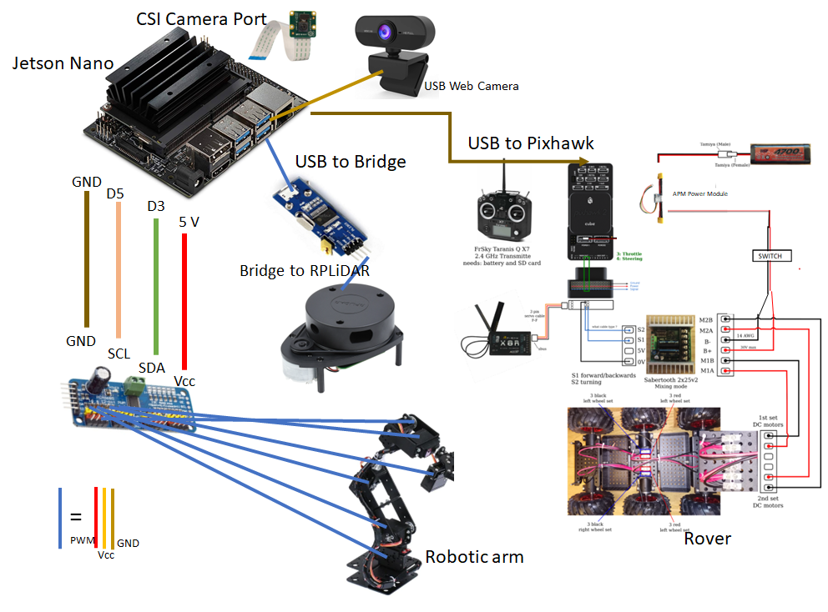

**CHAPTER 4: SOFTWARE COMPONENTS**

The software components utilized in this project play a crucial role in enabling the functionality and coordination of the planetary rover with a robotic arm. These software components provide the necessary tools, libraries, and algorithms for communication, control, perception, planning, and visualization. The following subsections outline the key software components used in the project and describe their respective roles in the system.

**4.1 MISSION PLANNER – GCS**

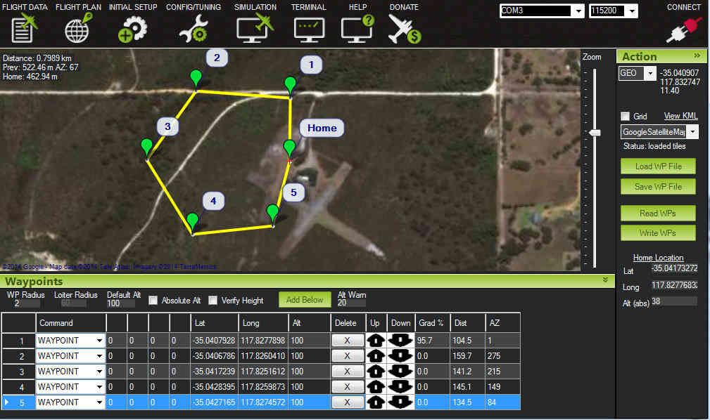Mission Planner is a powerful ground control station (GCS) software designed for planning, configuring, and monitoring autonomous missions of unmanned aerial vehicles (UAVs) or drones. As a GCS, Mission Planner serves as the primary interface between the user and the UAV system, enabling mission planning, real-time monitoring, and control of the vehicle.

The primary role of Mission Planner is to facilitate the planning and execution of autonomous missions. It provides a user-friendly graphical interface that allows users to define waypoints, set flight parameters, and specify mission objectives. These missions can include tasks such as aerial surveys, search and rescue operations, or exploration missions.

Mission Planner supports various autopilot systems and can communicate with the UAV through telemetry links, enabling bidirectional communication for monitoring the vehicle's status, telemetry data, and live video feed. It provides real-time information about the UAV's position, altitude, battery level, and sensor readings, allowing users to monitor the vehicle's performance and make informed decisions during the mission.

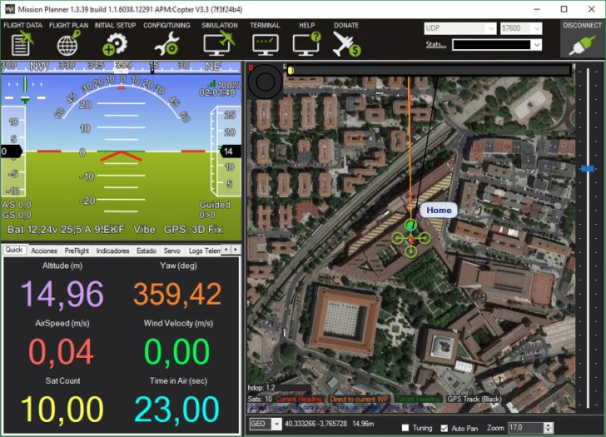Additionally, Mission Planner offers advanced features such as mission simulation, which allows users to test and validate mission plans before actual execution. It provides tools for graphically visualizing the planned mission, verifying waypoints, and checking for potential conflicts or obstacles. Mission Planner also supports data logging, enabling the collection and analysis of telemetry data for post-mission evaluation and analysis.

Another crucial aspect of Mission Planner is its capability to configure and tune the UAV's parameters. Users can adjust various parameters such as flight modes, control gains, and sensor settings to customize the behavior of the UAV according to mission requirements and environmental conditions. Mission Planner simplifies the parameter configuration process, providing a centralized and intuitive interface for making these adjustments.

Overall, Mission Planner is a versatile and comprehensive ground control station software that streamlines the planning, monitoring, and control of autonomous missions for UAVs. Its user-friendly interface, advanced features, and compatibility with different autopilot systems make it an invaluable tool for mission planning and execution, enhancing the capabilities and efficiency of the planetary rover system.

**4.2 DRONEKIT:**

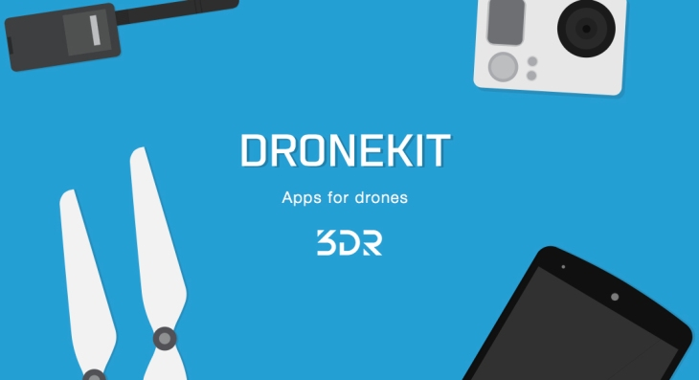

DroneKit is an open-source software development kit (SDK) that provides a powerful framework for building applications that communicate with unmanned aerial vehicles (UAVs) or drones. It offers a high-level API (Application Programming Interface) that simplifies the development process and allows developers to create custom control and mission planning applications.

DroneKit supports multiple programming languages, including Python and Android Java, making it accessible to a wide range of developers. By utilizing DroneKit, developers can interact with UAVs in a standardized and consistent manner, regardless of the specific autopilot or hardware being used.

The key functionality of DroneKit lies in its ability to communicate with the UAV and exchange commands, telemetry data, and other information. It provides an abstraction layer that encapsulates the complexity of low-level communication protocols, such as MAVLink, making it easier to focus on developing high-level control and mission planning features.

With DroneKit, developers can access real-time telemetry data from the UAV, including information about its position, altitude, battery level, sensor readings, and more. This data can be utilized to create custom flight control algorithms, implement intelligent decision-making processes, or monitor the UAV's status during missions.

One of the significant advantages of DroneKit is its support for mission planning and execution. It allows developers to define complex autonomous missions by specifying waypoints, controlling flight modes, and triggering actions based on specific events. Developers can define mission parameters such as speed, altitude, and duration, enabling the UAV to execute missions autonomously.

DroneKit also provides access to various advanced features, including geofencing, terrain following, and obstacle avoidance. These features enhance the UAV's capabilities and enable safer and more efficient flight operations. Developers can leverage these functionalities to create applications tailored to specific use cases, such as aerial mapping, infrastructure inspection, or precision agriculture.

Furthermore, DroneKit offers simulation capabilities, allowing developers to test their applications in virtual environments before deploying them to real UAVs. This facilitates the development and debugging process, ensuring the reliability and safety of the applications.

In summary, DroneKit empowers developers to build custom control and mission planning applications for UAVs. Its high-level API, support for multiple programming languages, and advanced features make it a valuable tool for creating intelligent and autonomous UAV systems. By utilizing DroneKit, developers can unlock the full potential of UAVs and tailor them to specific use cases and requirements.

**4.3 BLENDER**



Blender is a versatile and powerful open-source 3D computer graphics software that can be utilized for various purposes, including modeling, rendering, animation, and simulation. Blender plays a significant role in the project by enabling the creation of 3D models and facilitating visualization and simulation of the rover's interactions with the planetary environment.

One of the key applications of Blender in the project is the generation of 3D models of the planetary environment or objects within it. By utilizing Blender's modeling capabilities, users can create accurate representations of the terrain, structures, and objects that the rover may encounter during its mission. These 3D models can be based on existing data, such as satellite imagery or topographic maps, or they can be created from scratch using Blender's intuitive modeling tools.

The generated 3D models can be further enhanced through Blender's texturing and material capabilities, allowing for the realistic representation of surfaces, colors, and textures. This enables the project team to visualize and analyze the rover's interaction with the environment more effectively.

Additionally, Blender provides advanced rendering capabilities, allowing for the creation of high-quality visualizations and simulations. The rendered images and animations can help in understanding and evaluating different scenarios, such as the rover's movement, robotic arm manipulations, and object interactions within the planetary environment.

Moreover, Blender's physics simulation engine can be utilized to simulate realistic physics-based interactions. This can aid in evaluating the rover's stability, assessing the effects of gravity and friction on its movements, or testing the feasibility of certain maneuvers or object manipulations. The simulations can provide valuable insights into the rover's behavior and guide design decisions.

Furthermore, Blender offers animation tools that enable the creation of dynamic and realistic movement sequences. This can be beneficial for visualizing the rover's movements, showcasing different modes of operation, or demonstrating complex maneuvers of the robotic arm. The animations can aid in presentations, documentation, and communication of the rover's capabilities and functionality.

Overall, Blender serves as a powerful tool in the project, enabling the creation of 3D models, realistic visualizations, physics simulations, and animations. By leveraging Blender's capabilities, the project team can enhance their understanding of the rover's behavior in the planetary environment, visualize its operations, and communicate their findings effectively.

The most important use case of this software in this project was the creation of the URDF and SDF files of the robotic arm. This is pivotal for the automation of the arm using ROS and is the first step towards automation.

Unified Robotics Description Format, URDF, is an XML specification used in academia and industry to model multibody systems such as robotic manipulator arms for manufacturing assembly lines and animatronic robots for amusement parks.

SDFormat (Simulation Description Format), sometimes abbreviated as SDF, is an XML format that describes objects and environments for robot simulators, visualization, and control. Originally developed as part of the Gazebo robot simulator, SDFormat was designed with scientific robot applications in mind.



Phobos is both a CLI tool and add-on for the open-source 3D modeling software [Blender v3.3LTS](https://www.blender.org/download/lts/3-3/) to support your robot model creation and editing.

The Blender add-on enables the creation of WYSIWYG robot models for use in robot frameworks like [ROS](http://wiki.ros.org/) and [ROCK](https://github.com/rock-core) or in real-time simulations such as [MARS](https://github.com/rock-simulation/mars) or [Gazebo](http://gazebosim.org/). Phobos exports formats such as **URDF**, **SDF** or **SMURF** and common mesh formats (**Stereolithography** (.stl), **Wavefront** (.obj) or **Collada** (.dae)).

Phobos was initiated and is currently developed at the [Robotics Innovation Center](http://robotik.dfki-bremen.de/en/startpage.html) of the [German Research Center for Artificial Intelligence (DFKI)](http://www.dfki.de/) in Bremen, together with the [Robotics Group](http://www.informatik.uni-bremen.de/robotik/index_en.php) of the [University of Bremen](http://www.uni-bremen.de/en.html).

Phobos makes use of Blender's hierarchical object graph and its bone objects. These objects, normally used for animating 3D characters, allow to store 3D coordinate systems and apply constraints to their movements, for instance to restrict the movement of an object to a certain range on a specific axis.

This allows to replicate the links and joints defined in a **URDF** model and together with the hierarchical tree of parent and child objects, the complete, branching kinematic chain of a robot can be represented.

By attaching meshes or primitives to the bones, Phobos allows to add visual and collision objects to a model. Additional objects allow storing further information, e.g. centers of mass of each part of a robot, thus refining the physical representation.

Sensor objects can be added to correctly place and orient devices such as laser scanners, cameras or contact sensors.

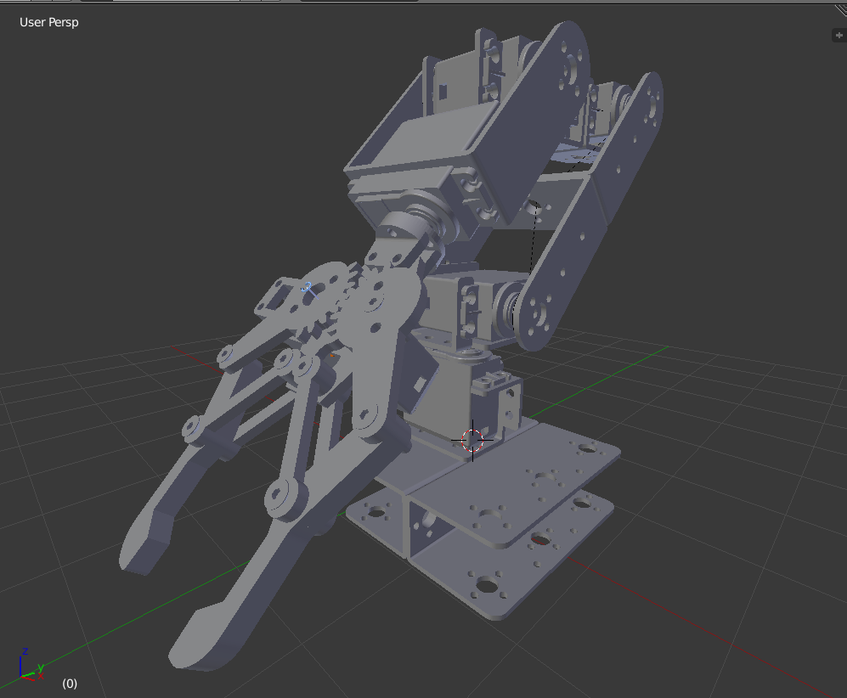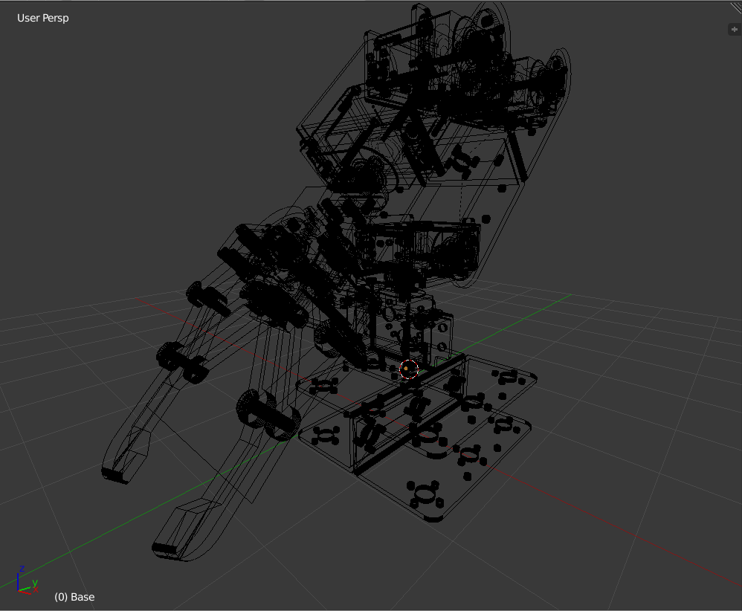Making use of Blender's custom object properties, any necessary information can be added to the model, from inertia tensors to opening angles of cameras.

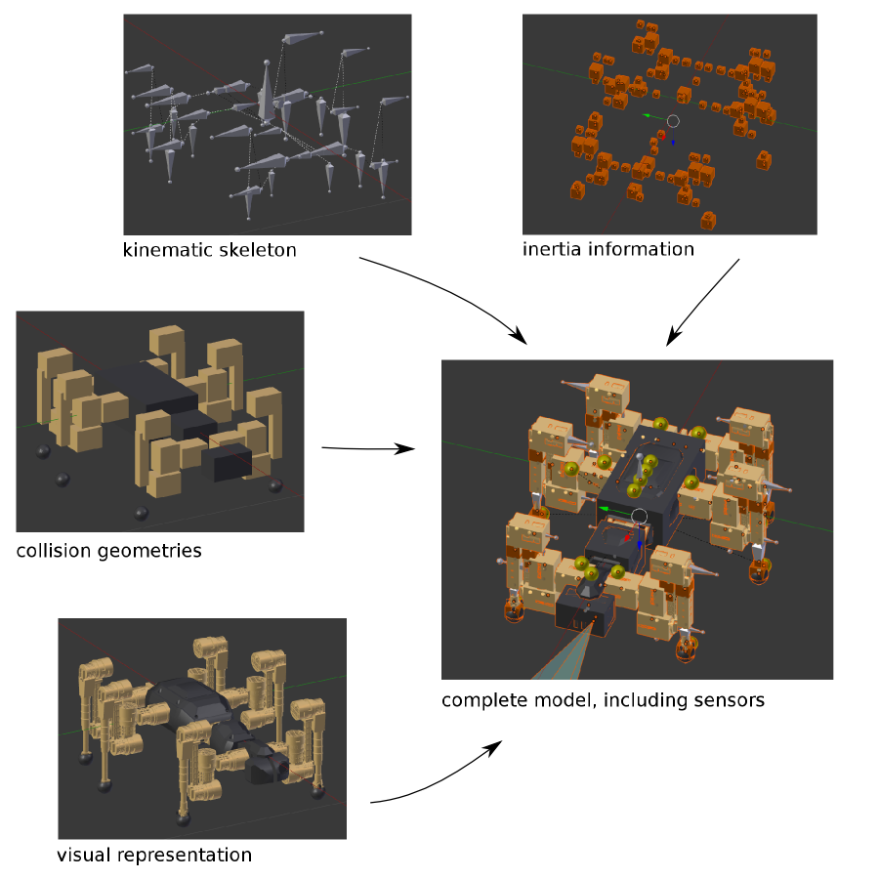

**4.4 JETSON NANO DEVELOPER KIT IMAGE**

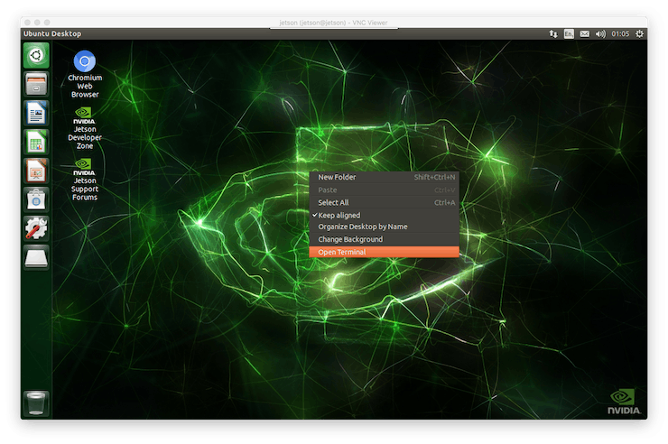

The Jetson Nano Developer Kit Image is a software image specifically designed for the Nvidia Jetson Nano, a small yet powerful single-board computer (SBC). The Jetson Nano Developer Kit Image serves as the operating system and software stack that runs on the Jetson Nano.

The image is pre-configured with the necessary software and drivers to utilize the full capabilities of the Jetson Nano. It typically includes an optimized Linux-based operating system, development libraries, tools, and other software components required for AI and robotics applications.

By utilizing the Jetson Nano Developer Kit Image, the project benefits from a ready-to-use software environment that supports the development and deployment of AI algorithms and robotic applications. The image takes advantage of the Jetson Nano's high-performance GPU and CPU architecture, allowing for efficient processing of complex algorithms, deep learning models, and computer vision tasks.

**4.5 UBUNTU 18.04**

Ubuntu 18.04 is an open-source Linux distribution widely used in the field of robotics and AI. It serves as the foundation for the software stack in the project and acts as the operating system on which the Jetson Nano Developer Kit Image is built.

Ubuntu 18.04 provides a stable and reliable operating system environment for running ROS and other software components required for the project. It is known for its compatibility with a wide range of hardware and software tools used in robotics and AI applications.

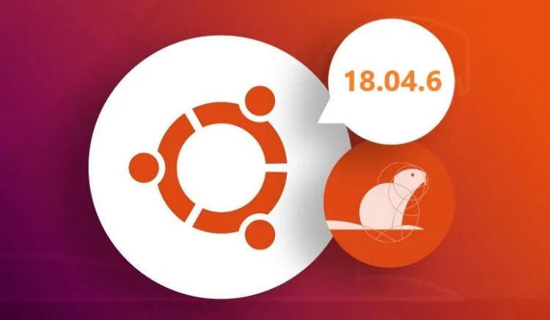

**4.6 ROS MELODIC**



ROS (Robot Operating System) is an open-source framework that provides a collection of software libraries, tools, and conventions for building robotic systems. It is designed to simplify the development of complex robot applications by offering a standardized and modular approach to software architecture.

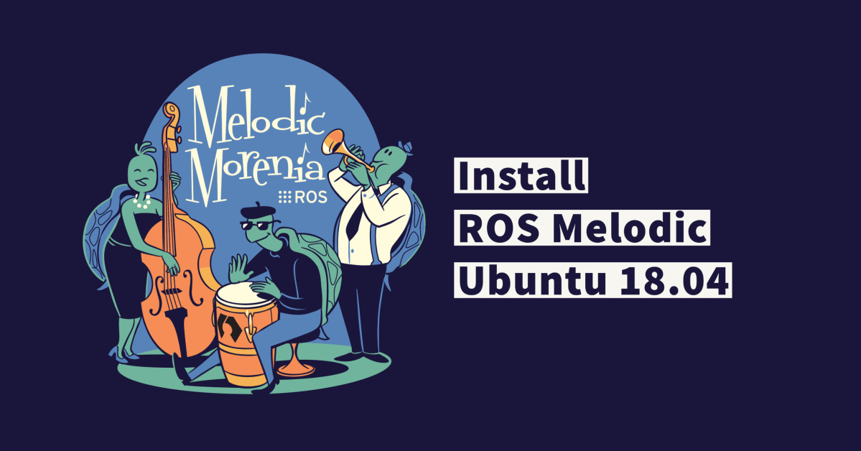ROS Melodic is one of the major releases of ROS and is widely used in the robotics community. It offers a stable and well-tested platform for developing robotic applications. ROS Melodic is specifically designed for Ubuntu 18.04, making it compatible with the Jetson Nano Developer Kit Image mentioned earlier.

ROS provides several key features that make it a powerful framework for robotics:

1. Communication: ROS implements a publish-subscribe messaging system, allowing different software components, called nodes, to exchange data and commands. This decoupled communication mechanism enables modular design, as nodes can be developed independently and easily connected.

2. Package Management: ROS utilizes a package-based architecture, where functionality is organized into packages containing nodes, libraries, configuration files, and other resources. The package management system simplifies the distribution, installation, and sharing of software components within the ROS ecosystem.

3. Tools and Utilities: ROS provides a rich set of tools and utilities for various development tasks. These include visualization tools like RViz, which enables 3D visualization of sensor data and robot models, and rqt, a framework for developing custom graphical user interfaces (GUIs) for ROS.

4. Message Passing: ROS uses a message format to define the structure of data exchanged between nodes. The message format provides a standardized way of representing sensor data, control commands, and other information, ensuring interoperability between different components of the system.

5. Services and Actions: In addition to the publish-subscribe mechanism, ROS supports service calls and actionlib, which allow nodes to request specific tasks or actions from other nodes. This enables more complex interactions and coordination between different components of the robot system.

6. Community and Ecosystem: ROS benefits from a large and active community of developers, researchers, and robotics enthusiasts. The community contributes to the development of new packages, shares knowledge and resources, and provides support through forums, mailing lists, and online documentation. This thriving ecosystem ensures that developers can leverage existing libraries, tools, and expertise to accelerate their development process.

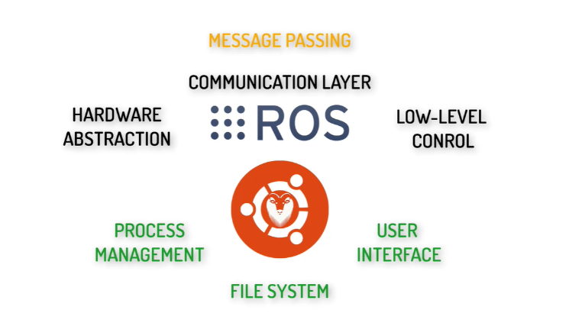

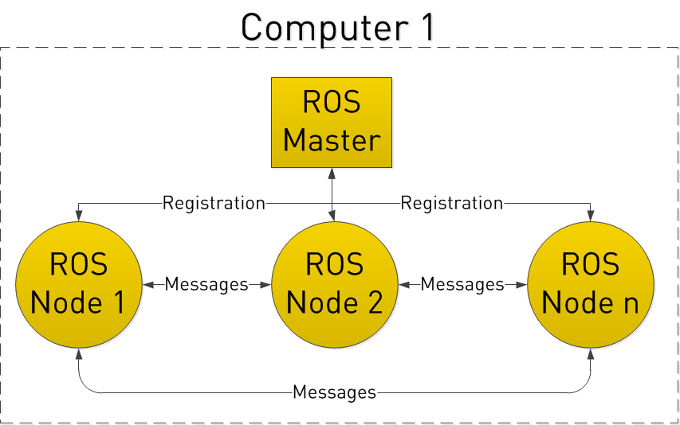

In ROS (Robot Operating System), communication is a fundamental aspect that enables the coordination and exchange of data between different software components, known as nodes. Nodes in ROS are individual software modules that perform specific tasks or provide specific functionalities within a robotic system.

The communication in ROS is based on a publish-subscribe model, where nodes can publish messages to a specific topic, and other nodes can subscribe to that topic to receive the messages. Topics act as the communication channels through which nodes share data with each other. Each message published on a topic is delivered to all nodes that have subscribed to that topic.

Nodes can publish messages to a topic at a specific rate or whenever new data becomes available. The messages can represent various types of data, such as sensor readings, control commands, or any other information required for the system's operation.

By using this publish-subscribe communication model, nodes in ROS can operate independently and asynchronously, allowing for a modular and distributed architecture. Nodes can be developed separately and easily connected together through the shared topics, promoting reusability and flexibility in the software design.

Additionally, ROS provides a variety of message types that define the structure and format of the data exchanged between nodes. These message types are defined in a specific format called ROS Message Description Language (msg), which describes the fields and data types contained in the message.

To establish communication between nodes, the ROS master node plays a crucial role. The ROS master node facilitates the registration and discovery of nodes, enabling them to find and communicate with each other. It keeps track of the available topics and their publishers and subscribers, allowing nodes to establish connections and exchange messages efficiently.

Furthermore, ROS provides additional communication mechanisms, such as services and actions, to support more complex interactions between nodes. Services allow nodes to request specific tasks or information from other nodes, while actions enable the execution of longer-running tasks with feedback and goal cancellation capabilities.

In summary, communication in ROS is based on a publish-subscribe model, where nodes exchange data through topics. This approach enables nodes to operate independently, promotes modularity and reusability, and facilitates the development of complex robotic systems. The ROS master node manages the communication infrastructure, while message types define the structure of the data exchanged between nodes.

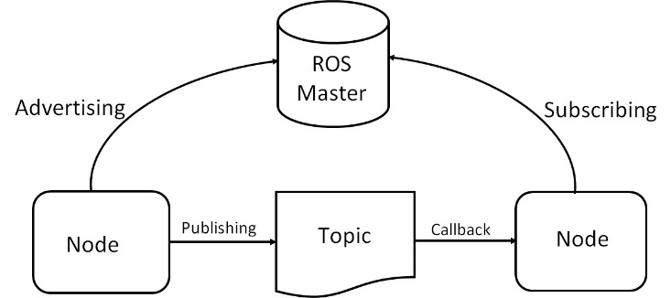

**4.7 MAVLINK**

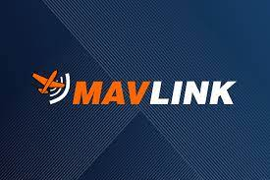MAVLink is a lightweight communication protocol designed specifically for unmanned systems, such as drones and ground control stations. It serves as a standard means of communication between different components of the system, including flight controllers, onboard computers, and ground control stations. MAVLink ensures reliable and efficient data exchange and control command transmission in a highly interoperable manner.

MAVLink defines a set of message types and commands that encapsulate information such as sensor data, control commands, vehicle status, and mission commands. These messages are serialized and transmitted over various communication channels, such as serial links, UDP, or TCP/IP connections. The protocol supports both telemetry data streaming and command messaging.

Being an industry-standard protocol, MAVLink is widely adopted and supported by various autopilot systems, including ArduPilot, PX4, and other popular UAV platforms. It allows seamless integration and interoperability between different hardware and software components within the UAV system.

In the project, MAVLink played a crucial role in establishing communication between the various components of the robotic system, including the Jetson Nano, flight controller, and ground control station. By utilizing MAVLink, we ensured reliable and efficient data exchange and control command transmission.

We integrated MAVLink into the software stack of the Jetson Nano, enabling it to communicate with the flight controller and receive telemetry data from the rover. MAVLink provided a standardized protocol for sending and receiving messages related to the rover's status, sensor data, and control commands.

Through MAVLink, we were able to establish a bidirectional communication channel between the Jetson Nano and the flight controller, allowing us to send commands to control the rover's movements and receive real-time telemetry data for monitoring its performance. This communication was critical for executing autonomous missions and performing object pick and drop operations using the robotic arm.

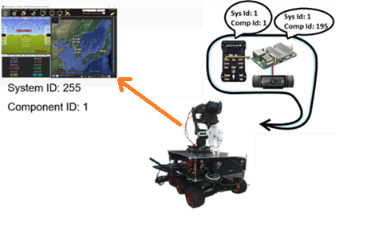

**4.8 MAVROS**

MAVROS is a ROS (Robot Operating System) package that provides a communication bridge between ROS and MAVLink-based autopilots, such as those used in drones and other unmanned vehicles. It enables seamless integration between ROS and MAVLink systems, allowing ROS nodes to interact with autopilots and access telemetry data, control commands, and other functionalities.

Here are some key features and functionalities of MAVROS:

**ROS and MAVLink Communication:** MAVROS establishes a bidirectional communication link between ROS and MAVLink-based autopilots. It provides ROS nodes with access to autopilot telemetry data, including sensor readings, vehicle state information, and global position data.

**ROS Services and Topics:** MAVROS exposes ROS services and topics that allow control and interaction with the autopilot. ROS nodes can send control commands to the autopilot, set waypoints, arm/disarm the vehicle, change flight modes, and more, using the provided ROS interfaces.

**Autopilot Parameter Control:** MAVROS allows for configuration and control of autopilot parameters from within the ROS ecosystem. Parameters such as PID gains, safety settings, navigation parameters, and other autopilot-specific settings can be modified using ROS services or command-line tools.

**Transformation Support:** MAVROS provides transformation support between ROS coordinate frames and the coordinate frames used by the autopilot. This allows for seamless integration with other ROS packages and navigation systems that rely on specific coordinate frame conventions.

**Simulation Support:** MAVROS includes features to support simulation environments. It can connect ROS nodes to simulated autopilots, enabling testing and development without the need for a physical vehicle. This is particularly useful for simulation-based testing and algorithm development.

**Diagnostic Messages:** MAVROS publishes diagnostic messages that provide status and error information from the autopilot to the ROS ecosystem. These messages can be used for monitoring, logging, and error handling within ROS nodes.

MAVROS simplifies the integration of MAVLink-based autopilots with the ROS ecosystem, allowing developers to leverage the powerful tools and capabilities of ROS for robotics applications. It provides a seamless communication bridge, enabling ROS nodes to interact with autopilots, access telemetry data, and control the vehicle's behaviour.

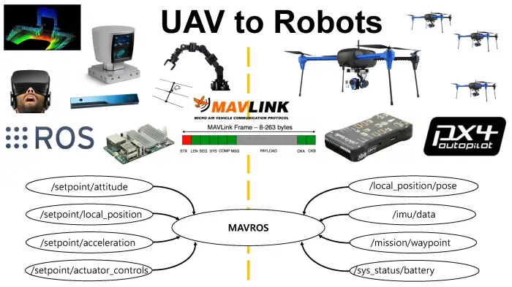

**4.9 MAVPROXY**

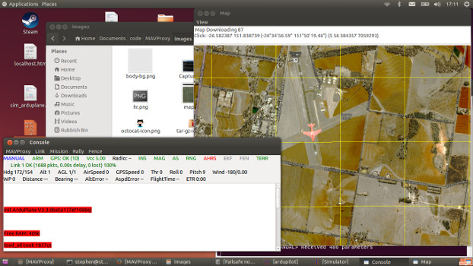

MAVProxy is a fully-functioning GCS for UAV’s, designed as a minimalist, portable and extendable GCS for any autonomous system supporting the MAVLink protocol (such as one using ArduPilot). MAVProxy is a powerful command-line based “developer” ground station software. It can be extended via add-on modules, or complemented with another ground station, such as Mission Planner, APM Planner 2, QGroundControl etc, to provide a graphical user interface.

It has a number of key features, including the ability to forward the messages from your UAV over the network via UDP to multiple other ground station software on other devices. MAVProxy is commonly used by developers (especially with SITL) for testing new builds.

tools can trace their origins to MAVProxy.

Features:

* It is a command-line, console-based app. There are plugins included in MAVProxy to provide a basic GUI.
* Can be networked and run over any number of computers.
* It’s portable; it should run on any POSIX OS with python, pyserial, and select() function calls, which means Linux, OS X, Windows, and others.
* The light-weight design means it can run on small netbooks with ease.
* It supports loadable modules, and has modules to support console/s, moving maps, joysticks, antenna trackers, etc
* Tab-completion of commands.

As a ground control station, MAVProxy offers a command-line interface that allows users to interact with the unmanned system directly. It provides access to vehicle status, mission planning, and command execution capabilities. Users can monitor telemetry data, set waypoints, change flight modes, and perform various other actions through MAVProxy.

The flexibility and extensibility of MAVProxy make it a valuable tool for developers, researchers, and UAV operators. It provides a lightweight and customizable ground control station solution that can be adapted to different scenarios and requirements. MAVProxy can be used as a standalone tool or integrated into larger UAV control systems..

**4.10 TELE OP KEYBOARD**

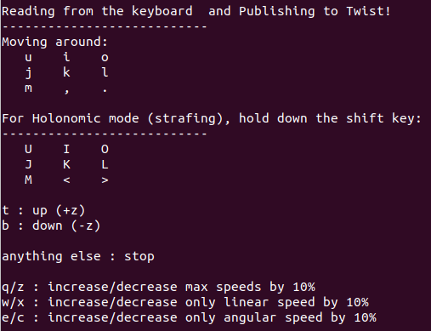

The TeleOp Keyboard is a ROS package that provides a user-friendly and intuitive keyboard interface for teleoperation of robotic systems. It enables manual control of the rover's movements, including driving and arm manipulation, using keyboard inputs.

The primary purpose of the TeleOp Keyboard package is to allow users to interactively control the rover without the need for complex control interfaces or specialized hardware. By utilizing a standard computer keyboard, users can easily send commands to the rover's control system for immediate response.

The TeleOp Keyboard package translates key presses into corresponding commands that are compatible with the rover's control system. It captures keyboard inputs and converts them into ROS messages, such as Twist messages, which represent linear and angular velocities.

One of the key concepts used in teleoperation with the TeleOp Keyboard package is the Twist message. The Twist message encapsulates the desired linear and angular velocities of the rover, allowing users to control its movement in a smooth and intuitive manner. For example, pressing the arrow keys can translate into forward or backward motion and turning left or right.

With the TeleOp Keyboard package, users can teleoperate the rover by simply running the package and using the keyboard to send commands. The package provides an efficient and convenient way to manually control the rover's movements, making it useful for testing, demonstration, and fine-tuning of the rover's capabilities.

The TeleOp Keyboard package enhances the user experience and provides a straightforward method for teleoperation of robotic systems using a standard computer keyboard. Its integration with ROS allows for seamless communication with the rover's control system, translating keyboard inputs into commands for driving and arm manipulation.

**4.11 MOVEIT**

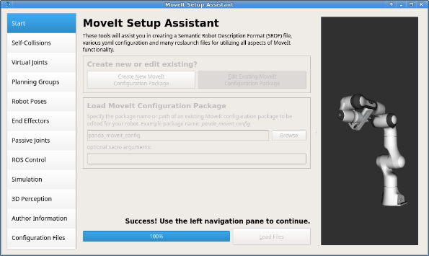 MoveIt is a widely-used ROS package for motion planning and control of robotic systems. It provides a powerful framework for manipulation tasks, including path planning, motion generation, and collision detection, making it well-suited for controlling the robotic arm in your planetary rover project.

Based on our previous conversation, MoveIt plays a crucial role in your project's implementation. Here is a detailed explanation of MoveIt in the context of your project:

1. Path Planning: MoveIt offers advanced path planning algorithms, such as the Probabilistic Roadmap Method (PRM) and the Rapidly-exploring Random Tree (RRT), which enable the generation of collision-free paths for the robotic arm. These algorithms consider the robot's kinematics, joint limits, and environmental obstacles to compute feasible trajectories.

2. Motion Generation: MoveIt provides tools to generate smooth and efficient motions for the robotic arm. It takes into account the robot's kinematic constraints, joint velocities, and dynamics to generate motion profiles that ensure accurate and safe arm movements.

3. Collision Detection: MoveIt incorporates collision detection algorithms to prevent the robotic arm from colliding with the environment or other objects. It uses the collision information from the robot's URDF model and the surrounding environment to perform real-time collision checking during planning and execution.

4. Grasping and Manipulation: MoveIt includes libraries and tools for grasp planning and manipulation. It allows you to define grasp poses, plan grasping motions, and execute them using the robotic arm. MoveIt's grasp planning capabilities can be utilized to optimize the robot's grasp strategy and improve object manipulation tasks.

5. Move Group: MoveIt's Move Group interface provides a high-level API to control the motion planning and execution of the robotic arm. It allows you to specify the desired joint configurations or end-effector poses, and Move Group automatically plans and executes the corresponding motions.

6. Visualization with RViz: MoveIt seamlessly integrates with RViz, a powerful visualization tool in ROS. RViz allows you to visualize the robot's configuration, planned paths, and collision objects. It provides an interactive interface to monitor and debug the motion planning process.

7. Integration with Robotic Arm URDF: MoveIt requires a robot's URDF (Unified Robot Description Format) model to represent its kinematics, joint limits, and collision properties. In your project, the URDF model of the robotic arm, which you created using Blender, can be loaded into MoveIt to enable accurate motion planning and collision checking.

8. MoveIt Configuration and Setup: MoveIt requires configuration and setup specific to your robotic arm. This includes defining the robot's kinematics, joint limits, end-effector properties, and collision objects in a MoveIt configuration file. This file defines the parameters and properties needed for MoveIt to accurately plan and execute motions for your specific robot.

Overall, MoveIt provides a comprehensive set of tools and functionalities that are essential for controlling and manipulating the robotic arm of your planetary rover. By utilizing MoveIt, you can leverage its advanced motion planning capabilities, collision detection, and grasp planning algorithms to perform complex object manipulation tasks with your rover's robotic arm.

**4.12 RVIZ**

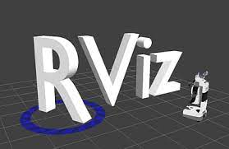

RViz is a powerful visualization tool in ROS that allows you to visualize and interact with various aspects of your robotic system. It has been discussed throughout our conversation and is an integral part of your project. Here is a detailed explanation of RViz based on the context of your project:

1. 3D Visualization: RViz provides a 3D visualization environment where you can view your robotic system, including the rover, robotic arm, sensors, and any other relevant objects. It allows you to visualize the robot's configuration, joint states, and movements in a simulated environment.

2. Robot Model Visualization: With RViz, you can load the URDF model of your robotic arm and rover. The URDF model defines the robot's physical structure, kinematics, joint limits, and visual representations. RViz uses the URDF model to render an accurate 3D representation of the robot in its current configuration.

3. Interactive Marker Controls: RViz offers interactive marker controls that enable you to interact with the robot model. You can select individual components of the robot, such as joints or end-effectors, and manipulate them using interactive controls. This allows you to manually move the robotic arm or change its configuration for testing and validation.

4. Path and Trajectory Visualization: RViz allows you to visualize planned paths and trajectories generated by motion planning algorithms such as MoveIt. You can display the planned paths in RViz to verify that they are collision-free and meet your desired objectives. This feature helps you assess the quality of the generated plans and make necessary adjustments if needed.

5. Sensor Data Visualization: RViz supports the visualization of sensor data such as point clouds, camera images, and laser scans. In your project, you can use RViz to display the data captured by your LIDAR sensor and cameras mounted on the rover. This visualization helps in assessing the quality of sensor data and validating the perception capabilities of the rover.

6. Collision Object Visualization: RViz allows you to display collision objects in the environment. This is particularly useful for visualizing obstacles, boundaries, or any other objects that could affect the motion planning process. You can add, modify, or remove collision objects in RViz to accurately represent the environment and ensure collision-free planning.

7. TF Visualization: RViz can visualize the transformations between different frames of reference using the TF (Transform) system in ROS. This feature is essential for visualizing the relationship between different components of your robotic system. For example, you can visualize the transformation between the base frame of the rover and the frame of the robotic arm to ensure proper alignment and coordination.

8. Interactive Control Panels: RViz provides interactive control panels that allow you to adjust various parameters and settings during runtime. These panels enable you to modify visualization properties, change the display of different elements, and control the behavior of the visualization environment. You can customize these panels to suit your specific requirements and facilitate easier interaction with the robot model.

9. Debugging and Validation: RViz serves as a valuable tool for debugging and validating your robotic system. It allows you to observe the behavior of the robot, monitor the execution of planned motions, and detect any potential issues or errors. By visualizing different aspects of your system in RViz, you can identify and resolve problems related to motion planning, perception, or control.

Overall, RViz plays a critical role in your project by providing a comprehensive visualization platform for your robotic system. Its features, such as 3D visualization, interactive marker controls, path visualization, sensor data display, and TF visualization, enable you to assess and validate the performance of your rover and robotic arm.

**4.13 PCA9685 ROS NODE**

The GitHub repository "https://github.com/dheera/ros-pwm-pca9685," is a ROS package for controlling the PCA9685 PWM (Pulse Width Modulation) driver. Here is a detailed explanation of this package:

1. Purpose: The "ros-pwm-pca9685" package provides a ROS interface for controlling the PCA9685 PWM driver. The PCA9685 is a popular hardware module that allows precise control of multiple PWM channels, making it suitable for controlling servos, motors, and other devices that require PWM signals.

2. Functionality: The package offers a set of ROS nodes and APIs that enable communication with the PCA9685 board and provide a convenient way to generate and send PWM signals to connected devices. It abstracts the low-level communication details and provides a high-level interface for interacting with the PCA9685.

3. ROS Nodes: The package includes ROS nodes that handle the communication with the PCA9685 board. These nodes subscribe to ROS topics or listen to ROS service calls to receive commands for setting PWM values on specific channels. They interface with the PCA9685 hardware and send the appropriate signals to control the connected devices.

4. PWM Control: The package allows you to specify the desired PWM values for individual channels of the PCA9685. By publishing messages or calling services associated with the PCA9685 node, you can set the PWM duty cycle or pulse width for each channel. This capability enables precise control of connected devices such as servos or motors.

5. Configuration: The package provides configuration options to specify the frequency of the PWM signals generated by the PCA9685. You can set the desired frequency in the package's configuration files or by passing parameters during runtime. This flexibility allows you to adapt the PWM output to match the requirements of your connected devices.

6. Compatibility: The "ros-pwm-pca9685" package is designed to work with ROS, making it compatible with the ROS ecosystem and other ROS-based components. It adheres to ROS conventions and integrates seamlessly into the ROS framework, allowing you to incorporate PCA9685 control into your ROS-based projects.

7. Example Usage: To use the package, you would typically include it as a dependency in your ROS workspace, clone the repository, and build the package using the appropriate ROS build commands. You can then configure the PCA9685 settings, such as the I2C address and frequency, in the package's configuration files. Once configured, you can publish messages to the appropriate ROS topic or call the ROS service provided by the package to set the PWM values on specific channels.

8. Integration with Robotic Systems: In the context of your project, the "ros-pwm-pca9685" package can be utilized to control the servo motors of the robotic arm. By publishing appropriate PWM values to the corresponding PCA9685 channels, you can precisely control the position and movement of the robotic arm's joints. This integration allows for seamless coordination between the robotic arm control and other components of your system.

Overall, the "ros-pwm-pca9685" package provides a convenient and ROS-compatible way to control the PCA9685 PWM driver. It simplifies the process of generating and sending PWM signals, making it easier to control servos, motors, and other devices requiring PWM control. By leveraging this package, you can effectively incorporate PCA9685 control into your ROS-based robotic projects.

4.14 ROBOT POSE PUBLISHER:

Robot Pose Publisher is a ROS package that publishes the pose (position and orientation) of a robot or specific links of the robot's body. It extracts the robot's pose information from the robot's joint states and publishes it as a ROS topic. The Robot Pose Publisher is useful for providing the pose information required for navigation, localization, and visualization purposes.

**4.14 SLAMTECH RPLIDAR ROS NODE**

The GitHub repository, "https://github.com/Slamtec/rplidar_ros," corresponds to the "rplidar_ros" package, which is a ROS driver for the RPLidar series of LIDAR sensors developed by Slamtec. Here is a detailed explanation of this package:

1. Purpose: The "rplidar_ros" package serves as a bridge between the RPLidar LIDAR sensor and ROS. It enables the integration of RPLidar sensors into ROS-based robotic systems, allowing you to utilize the sensor's range data for various applications such as mapping, localization, and obstacle detection.

2. RPLidar Sensors: Slamtec's RPLidar sensors are low-cost and lightweight LIDAR devices widely used in the robotics community. These sensors utilize laser scanning technology to provide 360-degree range measurements, allowing for accurate environment perception. The "rplidar_ros" package provides the necessary functionality to interface with these sensors in a ROS environment.

3. ROS Node: The package includes a ROS node that communicates with the RPLidar sensor. This node establishes a connection with the sensor and receives raw range measurements from it. It then processes the received data and publishes ROS topics containing the LIDAR scan information, such as distance measurements and corresponding angles.

4. Laser Scan Messages: The "rplidar_ros" package defines ROS message types, specifically the `sensor_msgs/LaserScan` message, for representing the range measurements acquired by the RPLidar sensor. These messages contain information about the distances and angles of the measured points, along with other relevant metadata.

5. Configuration: The package allows you to configure various parameters of the RPLidar sensor, such as the communication interface, data rate, and motor control. These configuration options can be modified using ROS parameters or specified in launch files, providing flexibility to adapt the settings based on your specific requirements.

6. Integration with ROS Ecosystem: The "rplidar_ros" package adheres to ROS conventions and integrates seamlessly with the ROS ecosystem. It can be used alongside other ROS packages for SLAM (Simultaneous Localization and Mapping), navigation, or perception tasks, enabling you to incorporate LIDAR data into your larger robotic system.

7. Example Usage: To use the package, you typically include it as a dependency in your ROS workspace, clone the repository, and build the package using the appropriate ROS build commands. Once built, you can launch the ROS node provided by the package, which establishes communication with the RPLidar sensor and starts publishing the LIDAR scan data on the corresponding ROS topics.

8. Benefits and Applications: By utilizing the "rplidar_ros" package, you can leverage the capabilities of RPLidar sensors within your ROS-based projects. These sensors are well-suited for mapping and localization tasks, allowing you to create accurate maps of the environment or perform localization within known maps. Additionally, the range data from the RPLidar can be used for obstacle detection and avoidance, enabling safe navigation of your robotic system.

9. Contribution and Community Support: The "rplidar_ros" package is an open-source project with an active community of contributors and users. The repository provides documentation, issue tracking, and discussion forums for users to seek help, report bugs, or contribute improvements to the package.

Overall, the "rplidar_ros" package facilitates the integration of Slamtec's RPLidar sensors into ROS-based robotic systems. By leveraging this package, you can utilize the range data from the RPLidar sensor for mapping, localization, obstacle detection, and other perception tasks in your ROS projects.

4.16 CARTOGRAPHER:

Cartographer is a powerful 2D and 3D simultaneous localization and mapping (SLAM) library. It provides algorithms and tools for creating highly accurate maps of an environment using sensor data, such as lidar and IMU. Cartographer is often used in robotics applications to build maps, localize the robot within those maps, and improve navigation capabilities.

**4.15 MOVE BASE**

The "move_base" package in ROS is a powerful and widely used navigation system that provides autonomous movement capabilities to mobile robots. It is a part of the ROS Navigation Stack and offers path planning, obstacle avoidance, and localization functionalities. Here is a detailed explanation of the "move_base" package:

1. Purpose: The main purpose of the "move_base" package is to enable mobile robots to autonomously navigate in their environment. It combines inputs from various sensors, such as laser scanners and odometry, to generate safe and optimal paths for the robot to follow. It provides a high-level interface for specifying navigation goals and handles the low-level control necessary to achieve them.

2. Components: The "move_base" package consists of several components working together:

- Global Planner: The global planner generates a global path from the robot's current location to the desired goal location. It takes into account the map of the environment, provided through the "/map" topic, and plans a path that avoids obstacles and respects the robot's kinematic constraints.

- Local Planner: The local planner is responsible for adjusting the robot's trajectory based on real-time sensor feedback. It uses the robot's current pose and sensor data, such as laser scans, to avoid dynamic obstacles and fine-tune the robot's path. The local planner operates in the robot's immediate vicinity and helps ensure smooth and safe navigation.

- Costmap: The costmap is a representation of the environment that assigns costs to different regions based on their traversability. It combines information from the global map and sensor data to create a grid representation with different cost values for different types of terrain or obstacles. The costmap is used by the planners to generate collision-free paths.

- Recovery Behaviors: The "move_base" package also includes recovery behaviors that help the robot overcome challenging situations. These behaviors, such as clearing a blocked path or attempting to rotate out of a deadlock, are triggered when the robot encounters unexpected obstacles or gets stuck.

3. Configuration: The "move_base" package requires proper configuration to suit the robot's specific setup and environment. The configuration involves defining parameters such as planner settings, sensor topics, robot footprint, maximum speeds, and recovery behavior strategies. By tuning these parameters, you can optimize the robot's navigation behavior for different scenarios.

4. Usage: To use the "move_base" package, you typically need to provide a map of the environment and configure the package's parameters according to your robot's characteristics. Once configured, you can send navigation goals to the package using a "goal" message, specifying the desired position and orientation in the global coordinate frame. The "move_base" package then plans a path and autonomously guides the robot to the goal while avoiding obstacles.

5. Integration with Other Components: The "move_base" package seamlessly integrates with other ROS components. It can work with sensor drivers, such as the RPLidar or camera nodes, to obtain perception data for obstacle avoidance. It can also utilize the "amcl" package for localization using odometry and laser scan information. Additionally, the "move_base" package can interact with higher-level decision-making systems or task planners to achieve complex robot behaviors.

Overall, the "move_base" package provides a comprehensive solution for autonomous navigation in ROS-based robotic systems. By combining global and local planning, costmaps, and recovery behaviors, it enables robots to navigate safely and efficiently in diverse environments. Its flexibility, integration capabilities, and extensibility make it a valuable tool for developing autonomous mobile robots.

**4.16 TF**

Here is a detailed explanation of the "tf" package and its relevance to our conversation:

Purpose: The "tf" package in ROS stands for "Transform Library." Its main purpose is to manage and broadcast coordinate transforms between different frames of reference within a robotic system. It enables the transformation of coordinates from one frame to another, facilitating the coordination of data from different sensors and components.

Coordinate Transforms: In a robotic system, various sensors, cameras, and actuators are typically located in different positions and orientations. The "tf" package allows us to express their measurements or commands in a common coordinate system. It provides a way to specify the relationship between different frames of reference, such as the base frame, sensor frames, and end-effector frames.

Transformation Tree: The "tf" package organizes the coordinate transforms in a hierarchical structure known as the Transformation Tree. This tree represents the relationships between frames and their parent-child connections. The tree structure allows for efficient and consistent transformations between frames at different levels of the hierarchy.

Broadcasters and Listeners: The "tf" package includes two main components: broadcasters and listeners. The broadcasters are responsible for publishing the coordinate transforms between frames, while the listeners receive and store these transforms for future use. This allows other components and nodes in the system to query and use the transforms as needed.

ROS Topics: The "tf" package uses ROS topics to publish and subscribe to the coordinate transform data. The main topic used is "/tf", which contains the transform information for all frames in the system. Additionally, the "/tf_static" topic is used for static transforms that do not change over time.

Coordinate Transformations in the Project: In our conversation, the "tf" package is relevant for managing coordinate transforms between different frames of reference. For example, it can be used to align the sensor data from the USB camera and CSI camera with the rover's base frame. By specifying the transforms between these frames, we can accurately integrate the visual information from the cameras into the robot's perception system.

Benefits and Applications: The "tf" package provides a powerful mechanism for handling coordinate transforms in ROS-based robotic systems. It ensures consistent and accurate spatial relationships between frames, which is crucial for sensor fusion, motion planning, and control. The ability to seamlessly integrate data from different sources simplifies the development of complex robotic systems.

Integration with Other Packages: The "tf" package is extensively used and integrated with other ROS packages. For instance, it is commonly used in conjunction with the "move_base" package for navigation, the "rviz" package for visualization, and the "robot_state_publisher" package for publishing the robot's state in the coordinate tree.

Documentation: The website "http://wiki.ros.org/tf" provides comprehensive documentation for the "tf" package, including tutorials, API references, and examples. It covers topics such as setting up coordinate frames, managing the transformation tree, using the broadcaster and listener APIs, and handling dynamic and static transforms.

Overall, the "tf" package plays a crucial role in managing coordinate transforms and maintaining spatial relationships between frames in ROS-based robotic systems. Its ability to handle coordinate transformations efficiently and accurately enhances the overall perception, planning, and control capabilities of the robot.

4.19 JETSON INFERENCE:

Jetson Inference is a software library designed for GPU-accelerated deep learning inference on the Nvidia Jetson platform. It provides a collection of tools, pre-trained models, and APIs to enable real-time object detection, image classification, and semantic segmentation on the Jetson Nano. Jetson Inference can be utilized for advanced perception tasks in the project, such as object recognition and manipulation.

**4.17 CARTOGRAPHER**

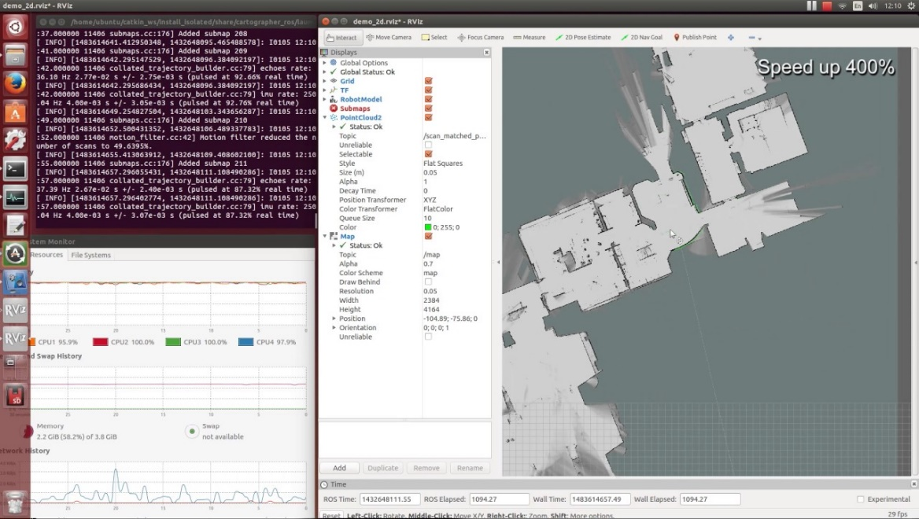

Cartographer is an open-source, real-time SLAM (Simultaneous Localization and Mapping) library developed by Google. It is designed to generate 2D and 3D maps of indoor and outdoor environments using data from various sensors, such as LIDAR (Light Detection and Ranging) and IMU (Inertial Measurement Unit).

Here are some key features and functionalities of Cartographer:

SLAM Capabilities: Cartographer utilizes sensor data to perform simultaneous localization and mapping. It combines data from LIDAR scans, IMU measurements, and optionally wheel odometry to estimate the robot's pose and create a map of the environment.

2D and 3D Mapping: Cartographer is capable of generating both 2D and 3D maps. It constructs a highly accurate representation of the environment by incorporating sensor measurements and optimizing the map based on the SLAM algorithm employed.

Loop Closure Detection: Cartographer includes loop closure detection, which allows it to identify areas that the robot has previously visited. This helps improve map accuracy by closing loops and correcting accumulated errors in the estimated trajectory.

Global Submap Generation: Cartographer divides the map into submaps and maintains a global map that can be continuously updated. This allows for efficient memory usage and map management, as well as the ability to operate in large-scale environments.

Real-Time Operation: Cartographer is optimized for real-time operation, enabling mapping and localization updates at high frequencies. This makes it suitable for applications that require accurate and up-to-date maps in real-world scenarios.

ROS Integration: Cartographer is integrated with the Robot Operating System (ROS), a popular framework for robotics development. It provides ROS interfaces and tools for easy integration with existing ROS-based robotic systems.

Cartographer has been widely adopted in robotics research and applications. It has proven to be effective in various domains, including autonomous vehicles, robotics navigation, augmented reality, and virtual reality. Its robust SLAM capabilities and integration with ROS make it a valuable tool for creating accurate maps of complex environments.

In our project, this package has been used alongside the RPLidar package by SLAMTEC for ROS and the AP_Navigation package by Ardupilot for ROS for mapping of the indoor environment and subsequently localization and autonomous missions.

Mapping of the environment was carried out by following the below steps:

**Install ROS**

* Install the ROS desktop full: sudo apt-get install ros-<distro>-desktop

**Create a Catkin WorkSpace**

* In your home directory:

cd $HOME

mkdir -p catkin_ws/src

cd catkin_ws

catkin_init_workspace

**Install RPLidar node**

* Install the RPLidar node in the workspace

cd $HOME/catkin_ws/src

git clone <https://github.com/Slamtec/rplidar_ros.git>

**Install Google Cartographer**

* Install some more packages

sudo apt-get install python-wstool python-rosdep ninja-build

* Re-initialise the workspace with [wstool](http://wiki.ros.org/wstool) then merge the cartographer_ros.rosinstall file and fetch code for dependencies.

cd $HOME/catkin_ws

wstool init src

wstool merge -t src https://raw.githubusercontent.com/googlecartographer/cartographer_ros/master/cartographer_ros.rosinstall

wstool update -t src

* Install proto3 and deb dependencies

src/cartographer/scripts/install_proto3.sh

sudo rosdep init # if error message appears about file already existing, just ignore and continue

rosdep update

rosdep install --from-paths src --ignore-src --rosdistro=melodic -y

* Clone the [Robot Pose Publisher](http://wiki.ros.org/robot_pose_publisher) package into the workspace

cd $HOME/catkin_ws/src

git clone https://github.com/GT-RAIL/robot_pose_publisher.git

Create the cartographer_ros launch file using your favourite editor (like “gedit”)

cd $HOME/catkin_ws/src/cartographer_ros/cartographer_ros/launch

gedit cartographer.launch

* Copy-paste the contents below into the file

<launch>

<param name="/use_sim_time" value="false" />

<node name="cartographer_node"

pkg="cartographer_ros"

type="cartographer_node"

args="-configuration_directory $(find cartographer_ros)/configuration_files -configuration_basename cartographer.lua"

output="screen">

<remap from="odom" to="/mavros/local_position/odom" />

<remap from="imu" to="/mavros/imu/data" />

</node>

<node name="cartographer_occupancy_grid_node"

pkg="cartographer_ros"

type="cartographer_occupancy_grid_node" />

<node name="robot_pose_publisher"

pkg="robot_pose_publisher"

type="robot_pose_publisher"

respawn="false"

output="screen" >

<param name="is_stamped" type="bool" value="true"/>

<remap from="robot_pose" to="/mavros/vision_pose/pose" />

</node>

<node pkg="tf" type="static_transform_publisher" name="base_to_laser_broadcaster" args="0 0 0 0 0 0 base_link laser 100" />

</launch>

* Create the cartographer.lua script using our favourite editor (like “gedit”)

cd $HOME/catkin_ws/src/cartographer_ros/cartographer_ros/configuration_files

gedit cartographer.lua

* Copy-paste the contents below into the file

include "map_builder.lua"

include "trajectory_builder.lua"

options = {

map_builder = MAP_BUILDER,

trajectory_builder = TRAJECTORY_BUILDER,

map_frame = "map",

tracking_frame = "base_link",

published_frame = "base_link",

odom_frame = "odom",

provide_odom_frame = true,

publish_frame_projected_to_2d = false,

use_odometry = false,

use_nav_sat = false,

use_landmarks = false,

num_laser_scans = 1,

num_multi_echo_laser_scans = 0,

num_subdivisions_per_laser_scan = 1,

num_point_clouds = 0,

lookup_transform_timeout_sec = 0.2,

submap_publish_period_sec = 0.3,

pose_publish_period_sec = 5e-3,

trajectory_publish_period_sec = 30e-3,

rangefinder_sampling_ratio = 1.,

odometry_sampling_ratio = 1.,

fixed_frame_pose_sampling_ratio = 1.,

imu_sampling_ratio = 1.,

landmarks_sampling_ratio = 1.,

}

MAP_BUILDER.use_trajectory_builder_2d = true

TRAJECTORY_BUILDER_2D.min_range = 0.05

TRAJECTORY_BUILDER_2D.max_range = 30

TRAJECTORY_BUILDER_2D.missing_data_ray_length = 8.5

TRAJECTORY_BUILDER_2D.use_imu_data = false

TRAJECTORY_BUILDER_2D.ceres_scan_matcher.translation_weight = 0.2

TRAJECTORY_BUILDER_2D.ceres_scan_matcher.rotation_weight = 5

TRAJECTORY_BUILDER_2D.use_online_correlative_scan_matching = true

TRAJECTORY_BUILDER_2D.real_time_correlative_scan_matcher.linear_search_window = 0.1

TRAJECTORY_BUILDER_2D.real_time_correlative_scan_matcher.translation_delta_cost_weight = 1.

TRAJECTORY_BUILDER_2D.real_time_correlative_scan_matcher.rotation_delta_cost_weight = 10

TRAJECTORY_BUILDER_2D.motion_filter.max_angle_radians = math.rad(0.2)

-- **for** current lidar only 1 **is** good value

TRAJECTORY_BUILDER_2D.num_accumulated_range_data = 1

TRAJECTORY_BUILDER_2D.min_z = -0.5

TRAJECTORY_BUILDER_2D.max_z = 0.5

POSE_GRAPH.constraint_builder.min_score = 0.65

POSE_GRAPH.constraint_builder.global_localization_min_score = 0.65

POSE_GRAPH.optimization_problem.huber_scale = 1e2

POSE_GRAPH.optimize_every_n_nodes = 30

**return** options

**Build the Packages**

cd $HOME/catkin_ws

catkin build

source devel/setup.bash

**Start Cartographer**

* Plug the RPLidarA1M8 into the companion computer and then open up four terminals and in each terminal type:

cd catkin_ws

source devel/setup.bash

* Then in Terminal1:

roscore

* In Terminal2:

roslaunch rplidar_ros rplidar.launch

* In Terminal3:

roslaunch cartographer_ros cartographer.launch

* In Terminal4:

roslaunch mavros apm.launch

For ease of use, a pre-built package is available in <https://github.com/ArduPilot/ardupilot_ros>. After cloning this repository, install the dependencies before use.

**Configure ArduPilot**

Connect to the flight controller with a ground station (i.e. Mission Planner) and check that the following parameters are set as shown below:

* [AHRS_EKF_TYPE](https://ardupilot.org/copter/docs/parameters.html#ahrs-ekf-type) = 3 to use EKF3
* [EK2_ENABLE](https://ardupilot.org/copter/docs/parameters.html#ek2-enable) = 0 to disable EKF2
* [EK3_ENABLE](https://ardupilot.org/copter/docs/parameters.html#ek3-enable) = 1 to enable EKF3
* [EK3_SRC1_POSXY](https://ardupilot.org/copter/docs/parameters.html#ek3-src1-posxy) = 6 to set position horizontal source to ExternalNAV
* [EK3_SRC1_POSZ](https://ardupilot.org/copter/docs/parameters.html#ek3-src1-posz) = 1 to set position vertical source to Baro
* [EK3_SRC1_VELXY](https://ardupilot.org/copter/docs/parameters.html#ek3-src1-velxy) = 6 to set velocity horizontal source to ExternalNAV
* [EK3_SRC1_VELZ](https://ardupilot.org/copter/docs/parameters.html#ek3-src1-velz) = 6 to set vertical velocity source to ExternalNAV
* [EK3_SRC1_YAW](https://ardupilot.org/copter/docs/parameters.html#ek3-src1-yaw) = 6 to set yaw source to ExternalNAV
* [GPS_TYPE](https://ardupilot.org/copter/docs/parameters.html#gps-type) = 0 to disable the GPS
* [VISO_TYPE](https://ardupilot.org/copter/docs/parameters.html#viso-type) = 1 to enable visual odometry
* [ARMING_CHECK](https://ardupilot.org/copter/docs/parameters.html#arming-check) = 388598 (optional, to disable GPS checks)

After changing any of the values if available above, reboot the flight controller.

If needed, change **SYSID_MYGCS** to 255.

If all is working, vision position estimates should begin flowing in from ROS to ArduPilot. This can be confirmed by connecting to the flight controller using the Mission Planner (or similar) and check the Flight Data screen’s Messages tab (bottom left) for messages from the EKF like below:

EKF2 IMU1 initial pos NED = 0.0,0.0,0.0 (m)

EKF2 IMU1 **is** using external nav data

EKF2 IMU0 initial pos NED = 0.0,0.0,0.0 (m)

EKF2 IMU0 **is** using external nav data

Using the Mission Planner (or similar) go to the Flight Data screen and right-mouse-button click on the map and select “Set Home Here” >> “Set EKF Origin”. The vehicle should appear immediately on the map where you clicked.

If working on Jetson Nano only, MAVProxy can be installed and used for the above step.

**Testing**

To confirm the ROS side is working correctly type the command below and live updates of position estimates from cartographer should be displayed:

rostopic echo /robot_pose

[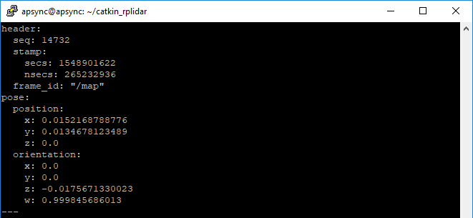](https://ardupilot.org/dev/_images/ros-cartographer-testing.png)

Mission Planner’s MAVLink Inspector (press Ctrl-F and then press the “MAVLink Inspector” button) can be used to check if VISION_POSITION_ESTIMATE messages are being successfully sent to the flight controller

[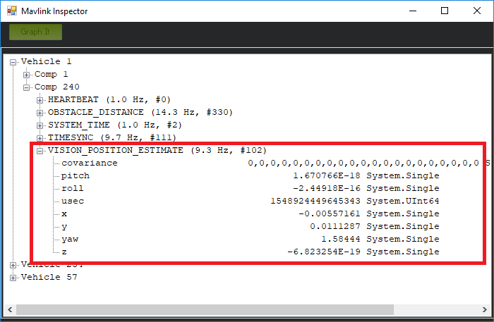](https://ardupilot.org/dev/_images/ros-cartographer-testing-mavlink-inspector.png)

After following these steps, start teleop_twist_keyboard and move the rover around the environment to get the data and the map.

To save the map in pgm and yaml file: rosrun map_server map_saver -f mapname

To save as pbstream file (useful for localization using Cartographer):

*# Finish the first trajectory. No further data will be accepted on it.*

rosservice call /finish_trajectory 0

*# Ask Cartographer to serialize its current state.*

*# (press tab to quickly expand the parameter syntax)*

rosservice call /write_state "{filename: '*${*HOME*}*/Downloads/b3-2016-04-05-14-14-00.bag.pbstream', include_unfinished_submaps: "true"}"

The indoor environment’s map captured in pgm format:

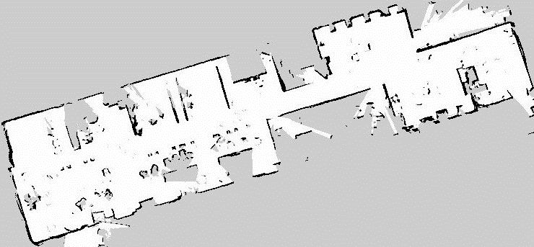

Now, following the steps from the cartographer official website, we make changes to the lua file as well as the launch file as follows:

Add -load_state_filename /path/to/pbstream to the cartographer node part of cartographer.launch as follows:

<node name="cartographer_node" pkg="cartographer_ros" type="cartographer_node" args="-load_state_filename $MAP_NAME.pbstream" />

In cartographer.lua file, add:

TRAJECTORY_BUILDER.pure_localization_trimmer = {

max_submaps_to_keep = 3,

}

Further tuning may be done in the lua file for better performance in localization only mode.

After doing so, following steps help in mission planning and execution:

**Start rviz**

* On the client PC start rviz

rosrun rviz rviz

* To see a real-time Lidar data
  + In the Display area, select “Add”, “LaserScan”
  + once added, expand the “LaserScan” section and set “Topic” to “/scan”
* To see a map of the environment
  + select “Add”, “Map”
  + once added, expand the “Map” section and set the “Topic” to “/map”
* To see the vehicle’s current heading (according to ROS)
  + select “Add”, “Pose”
  + once added, expand the “Pose” section and set the “Topic” to “/mavros/vision_pose/pose”

**Sending Position Targets**

* To allow ROS to send position targets to ArduPilot via mavros, log onto the Companion Computer running ROS and modify mavros’s node.launch file with your favourite editor (like gedit shown below)

roscd mavros <-- this assumes mavros has been installed **with** rosdep

cd launch

sudo gedit node.launch

* After <rosparam command="load" file="$(arg config_yaml)" /> add a line like below and restart the all ROS processes

<remap from="/mavros/setpoint_position/local" to="/move_base_simple/goal" />

* Arm the vehicle and switch to Guided mode
* From within rviz, click the “2D Nav Goal” button and then click and hold the mouse button on the map to aim the green arrow (this sets the target position and final attitude) and then release the mouse button
* The ground station should show the target position that the vehicle is moving towards (Mission Planner drops a green marker at the target position and draws an orange line towards the target from the vehicle)

For object avoidance functionality and movement:

* After <rosparam command="load" file="$(arg config_yaml)" /> add a line like below

<remap from="/mavros/setpoint_velocity/cmd_vel_unstamped" to="/cmd_vel" />

* Install ros-kinetic-navigation package

sudo apt-get install ros-kinetic-navigation

* Download [ArduPilot/companion/Common/ROS/ap_navigation.zip](https://github.com/ArduPilot/companion/tree/master/Common/ROS) to the catkin_ws/src directory

cd ~/catkin_ws/src

wget https://github.com/ArduPilot/companion/raw/master/Common/ROS/ap_navigation.zip

unzip ap_navigation.zip

* Rebuild all packages including ap_navigation

cd ~/catkin_ws

source devel/setup.bash

catkin build

**Start ap_navigation**

* restart all packages (roscore, rplidar, mavros and cartographer) and then start ap_navigation package

cd ~/catkin_ws

source devel/setup.bash

roslaunch ap_navigation ap_nav.launch

**Sending Position Targets**

* Arm the vehicle and switch to Guided mode
* Use [rviz](https://ardupilot.org/dev/docs/ros-rviz.html#ros-rviz)’s “2D Nav Goal” button to set a position target. If all goes well a green line will appearing showing the route the vehicle will take to the target (see image)

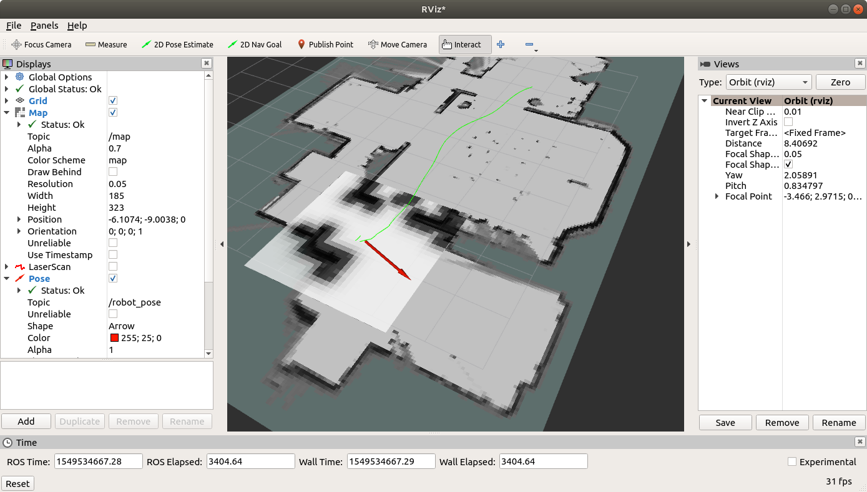

For better performance and improved response, these steps were also used:

**Mavros Configuration**

Mavros’s [apm_config.yaml](https://github.com/mavlink/mavros/blob/master/mavros/launch/apm_config.yaml) file can be modified to configure the rate of the [SYSTEM_TIME](https://mavlink.io/en/messages/common.html#SYSTEM_TIME) and [TIMESYNC](https://mavlink.io/en/messages/common.html#TIMESYNC) messages. Below are the recommended settings:

conn:

timesync_rate: 10.0

system_time_rate: 1.0

time:

timesync_mode: MAVLINK

**ArduPilot Configuration**

The flight controller’s time is set from the GPS by default but can be set from one of three sources(GPS, MAVLINK, onboard HW clock) using the [BRD_RTC_TYPES](https://ardupilot.org/rover/docs/parameters.html#brd-rtc-types) parameter as a bit mask for the time syncronisation source. When using mavros set BRD_RTC_TYPES = 2 to only allow the “MAVLINK_SYSTEM_TIME” source which uses the [SYSTEM_TIME](https://mavlink.io/en/messages/common.html#SYSTEM_TIME) MAVLINK message.

If the RTT too high for timesync message is shown in the Mavros console (most commonly when using ArduRover), the [SCHED_LOOP_RATE](https://ardupilot.org/rover/docs/parameters.html#sched-loop-rate) parameter should be increased. This is because Mavros ignores TIMESYNC messages if the round trip time is more than 10ms.

**Testing**

A MAVLink inspector (available using QGC or MissionPlanner) can be used to check that the system times are synchronised. If using Mission Planner, press Ctrl-F and push the “MAVLink Inspector” button.

[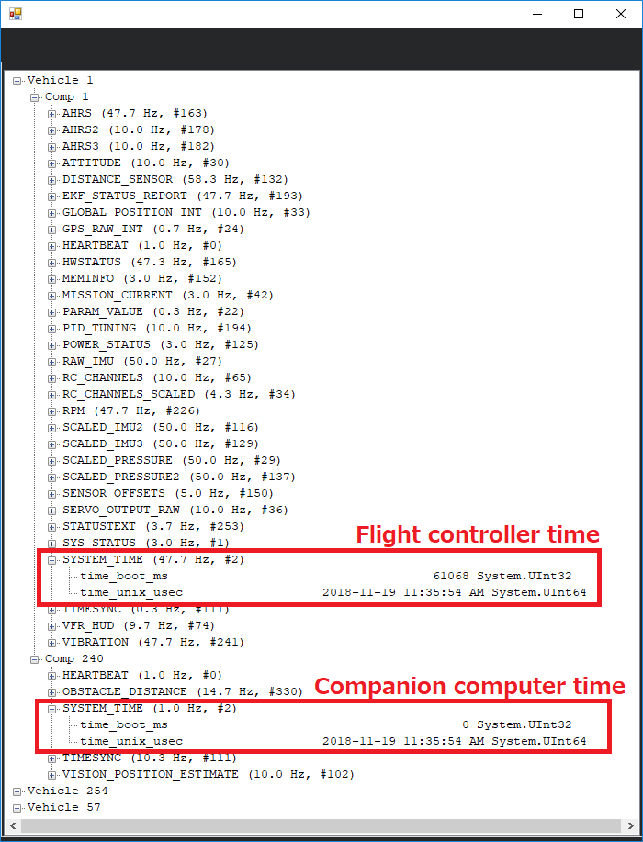](https://ardupilot.org/dev/_images/ros-time-sync-testing.png)

**4.18 GSTREAMER**

Gstreamer is an open-source multimedia framework that provides a pipeline-based architecture for handling multimedia data. It offers a comprehensive set of libraries, plugins, and tools for creating, manipulating, and streaming audio and video content. Gstreamer is widely used in various applications, including media players, video editors, streaming servers, and embedded systems. Here is a detailed explanation of Gstreamer and its relevance to the project:

1. Multimedia Framework: Gstreamer is designed as a flexible and modular multimedia framework. It provides a set of libraries and plugins that can be used to build custom multimedia applications or integrate multimedia capabilities into existing software systems.
2. Pipeline Architecture: The core concept of Gstreamer is the pipeline, which represents the flow of multimedia data from its source to its destination. A pipeline consists of multiple elements that perform specific tasks, such as capturing, decoding, encoding, filtering, and rendering audio and video data.
3. Elements and Plugins: Gstreamer provides a wide range of elements, which are the building blocks of a pipeline. Each element performs a specific function, such as reading data from a file, processing audio or video, or outputting the data to a display or network. Gstreamer also supports various plugins that extend its functionality by providing additional elements or codecs for handling different media formats.
4. Data Flow and Connections: Elements in a Gstreamer pipeline are connected together using pads, which represent input or output points of an element. The pads allow the flow of multimedia data between elements, enabling data processing and transformation within the pipeline.
5. Real-Time Processing: Gstreamer is designed for real-time multimedia processing, making it suitable for applications that require low-latency audio and video processing, such as streaming, conferencing, and interactive media applications.
6. Integration with Hardware Acceleration: Gstreamer provides support for hardware acceleration through various plugins and libraries. This enables the utilization of specialized hardware resources, such as GPUs, DSPs, or dedicated media processing units, to enhance performance and efficiency in multimedia processing.
7. Cross-Platform and Language Support: Gstreamer is cross-platform and can be used on various operating systems, including Linux, macOS, Windows, and embedded platforms. It also provides bindings for multiple programming languages, such as C, C++, Python, Java, and more, allowing developers to work with Gstreamer using their preferred language.
8. Streaming Capabilities: Gstreamer includes plugins and protocols for streaming media over networks, such as RTP (Real-Time Transport Protocol), RTSP (Real-Time Streaming Protocol), HTTP, and others. This enables the creation of multimedia streaming applications for live broadcasting, video on demand, and other streaming scenarios.

In summary, Gstreamer is a powerful and flexible multimedia framework that provides the necessary tools and capabilities for handling audio and video data in various applications. Its pipeline-based architecture, extensive plugin ecosystem, cross-platform support, and streaming capabilities make it a valuable tool for multimedia processing and integration in the project. By leveraging Gstreamer, developers can effectively manage multimedia data, perform real-time processing, and integrate media capabilities into the overall system architecture.

**4.19 JETSON INFERENCE**

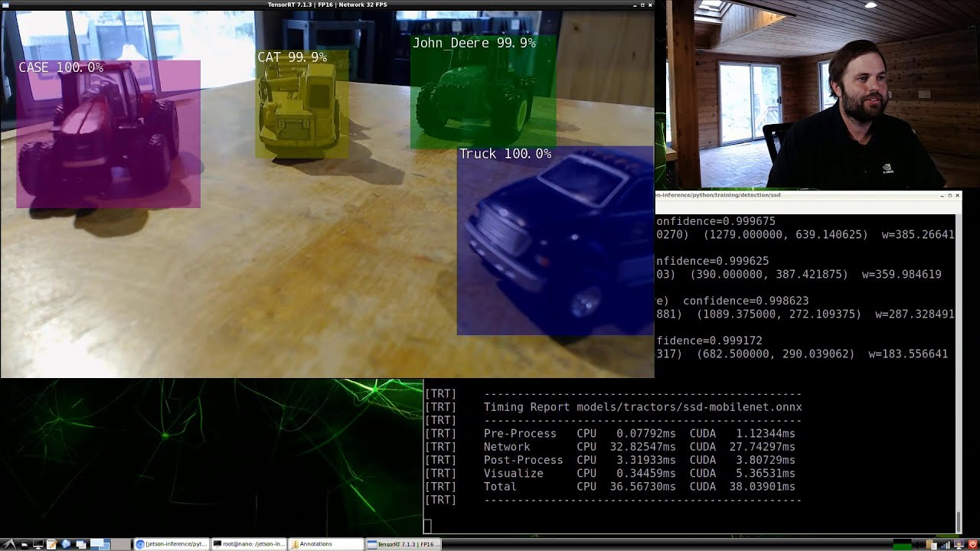

Jetson Inference is an open-source deep learning inference library specifically designed for NVIDIA Jetson devices, including the Jetson Nano mentioned in the project. It provides a framework for deploying and running pre-trained deep learning models on Jetson platforms, enabling real-time inference for tasks such as object detection, image classification, and segmentation. Here is a detailed explanation of Jetson Inference and its relevance to the project:

1. Deep Learning Inference: Jetson Inference focuses on the inference phase of deep learning, which involves using pre-trained neural network models to make predictions on new input data. It leverages the power of GPUs and the CUDA architecture to accelerate the computationally intensive operations required for deep learning inference.

2. Pre-trained Models: Jetson Inference comes with a collection of pre-trained models that have been trained on large-scale datasets for various computer vision tasks. These models include popular architectures like ResNet, MobileNet, and SSD (Single Shot MultiBox Detector), which are widely used for object detection and image classification.

3. Neural Network Acceleration: NVIDIA Jetson devices, including the Jetson Nano, are equipped with dedicated hardware accelerators, such as the CUDA cores and Tensor Cores, which provide high-performance computing for deep learning tasks. Jetson Inference takes advantage of these hardware features to optimize the inference process and achieve real-time performance.

4. Integration with Jetson Platforms: Jetson Inference is specifically designed for NVIDIA Jetson devices, ensuring seamless integration and compatibility with the Jetson software stack. It leverages CUDA, cuDNN (CUDA Deep Neural Network library), and other GPU-accelerated libraries to achieve efficient deep learning computations on Jetson platforms.

5. Easy Deployment and Usage: Jetson Inference provides a user-friendly interface and APIs that simplify the deployment and usage of pre-trained models on Jetson devices. Developers can quickly deploy the models and perform inference using just a few lines of code, making it accessible even to those with limited deep learning expertise.

In summary, Jetson Inference is a powerful and optimized deep learning inference library tailored for NVIDIA Jetson devices. It enables the deployment and execution of pre-trained deep learning models on Jetson platforms, providing real-time inference capabilities for computer vision tasks. By leveraging Jetson Inference, the project can perform advanced object detection, image classification, and other deep learning-based tasks on the Jetson Nano, allowing for intelligent decision-making and interaction with the environment.

**4.20 XRDP**

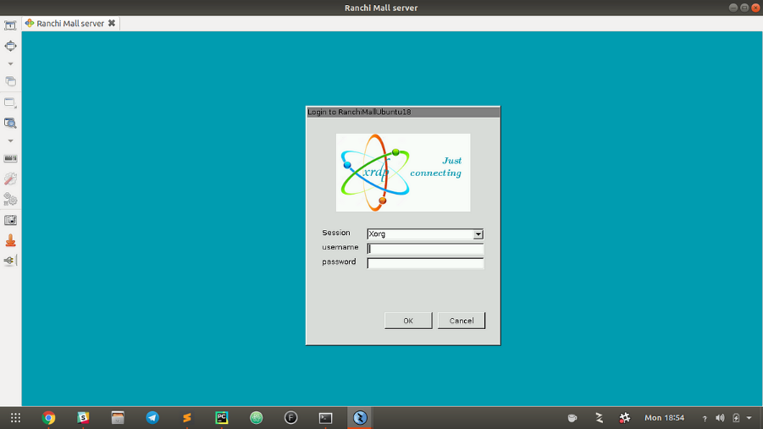XRDP, or X Remote Desktop Protocol, is an open-source remote desktop solution that allows users to access a graphical desktop environment on a remote machine. It enables remote desktop connections between a client device and a server, providing a user-friendly interface for remote access and control. Here is a detailed explanation of XRDP and its relevance to our conversation:

1. Purpose: The main purpose of XRDP is to facilitate remote desktop access to a remote machine, typically running a Linux operating system. It allows users to connect to the remote machine and interact with its graphical user interface (GUI) as if they were physically present in front of the machine.
2. Integration with ROS Project: In our conversation, XRDP is relevant for remotely controlling and monitoring the rover's activities. By configuring XRDP on the rover's system, you can establish a remote desktop connection to the rover from a client device. This enables you to control the rover, monitor its sensors, view camera feeds, and interact with the ROS-based software components remotely.
3. Setup and Configuration: Setting up XRDP involves installing the necessary packages and configuring the remote desktop environment. The specific steps may vary depending on the Linux distribution being used. Once XRDP is installed and configured, users can connect to the remote machine using an RDP client application by providing the IP address or hostname of the server.
4. Benefits and Applications: XRDP offers several benefits and finds applications in various scenarios, including:
   1. Remote Administration: XRDP enables system administrators to remotely manage and administer Linux machines, simplifying tasks such as software installations, updates, configuration changes, and troubleshooting.
   2. Remote Access for Collaboration: XRDP facilitates remote access and collaboration among team members working on the same ROS project. It allows multiple users to connect to the rover simultaneously and contribute to its control and operation.
   3. Remote Monitoring and Debugging: XRDP enables developers and researchers to remotely monitor the rover's activities, view sensor data, and debug ROS nodes and components. This remote access capability simplifies the process of analyzing and troubleshooting issues in the field.
5. Documentation and Support: XRDP has comprehensive documentation available, including installation guides, configuration instructions, and troubleshooting tips. The open-source nature of XRDP ensures an active community of users and developers who provide support and contribute to its ongoing development and improvement.

Overall, XRDP offers a convenient and secure solution for remote desktop access to Linux machines. Its integration into the ROS project allows for remote control, monitoring, and collaboration, enhancing the usability and flexibility of the rover system.

**4.21 WEBSOCKET**

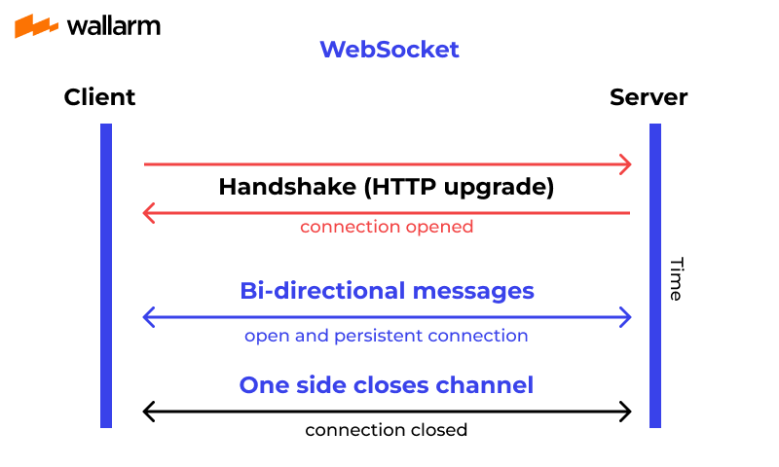Websockets are a communication protocol that enables two-way communication between a client and a server over a single, long-lived connection. It provides a persistent connection, allowing real-time data transfer and bidirectional communication between the client and the server. In the context of the project, websockets can be used to facilitate communication between different components of the system, such as the control interface (client) and the robotic rover (server). Here is a detailed explanation of websockets and their relevance to the project:

1. Real-time Communication: Websockets enable real-time communication between the client and the server. Unlike traditional HTTP requests, which are stateless and require the client to initiate communication, websockets establish a persistent connection that allows both the client and the server to send data to each other in real time.

2. Bi-Directional Communication: Websockets support bidirectional communication, meaning that both the client and the server can send and receive data. This is crucial for the project as it involves controlling the robotic rover and receiving updates or feedback from the rover during its operation.

3. Low Latency: Websockets offer low latency communication since the connection is kept open throughout the session, eliminating the need for repeated handshakes and reducing the overhead associated with establishing new connections for each request. This is essential for maintaining responsive and real-time control over the robotic rover.

4. Asynchronous Data Transfer: Websockets allow asynchronous data transfer, meaning that data can be sent or received independently of other operations. This enables parallel processing of data and ensures that the control interface can receive updates from the rover or send commands without waiting for a response.

5. Event-Driven Architecture: Websockets are event-driven, which means that data is transmitted based on specific events or triggers. For example, when the client sends a command to the rover, the server can respond with the corresponding action or acknowledge the command's execution by sending an event back to the client.

6. Compatibility and Accessibility: Websockets are supported by most modern web browsers and can be easily implemented using popular programming languages and frameworks. This makes them accessible and compatible across different platforms, allowing for a wide range of control interfaces to interact with the robotic rover.

In the project, websockets can be used to establish a connection between the control interface (client) and the robotic rover (server), allowing for real-time and bidirectional communication. The control interface can send commands to control the movement or actions of the rover, and the rover can provide updates, sensor data, or status information back to the control interface. This enables seamless and interactive control over the rover's behavior, facilitating efficient operation and monitoring during its tasks.

**4.22 FOXGLOVE**



Foxglove is a powerful and versatile toolset for ROS (Robot Operating System) developers that simplifies the process of building, debugging, and monitoring ROS-based applications. It provides a user-friendly graphical interface and a suite of features that facilitate the development and debugging of robotic systems. Here is a detailed explanation of Foxglove and its relevance to our conversation:

1. Purpose: The main purpose of Foxglove is to enhance the development and debugging experience for ROS applications. It offers a set of tools and features that enable developers to visualize, interact with, and monitor the data flowing through the ROS system, making it easier to understand and debug complex robotic applications.

2. Graphical Interface: Foxglove provides an intuitive and user-friendly graphical interface that allows developers to visualize the ROS system's components, messages, topics, and services. The interface presents the information in a structured and organized manner, making it easier to navigate and comprehend the overall system architecture.

3. Data Visualization: One of the key features of Foxglove is its ability to visualize ROS data in real-time. It allows developers to inspect and monitor the data being published on ROS topics, visualize message contents, and track changes over time. This visualization capability is particularly useful for debugging and gaining insights into the behavior of the robotic system.

4. Message Inspection: Foxglove enables developers to inspect the content and structure of ROS messages. It provides a detailed view of message fields, including their data types and values. This feature is helpful for understanding the data being transmitted and ensuring its correctness and consistency within the system.

5. Message Recording and Playback: Foxglove allows developers to record and replay ROS messages. This feature is beneficial for capturing data during experiments or real-world scenarios and later analyzing it in detail. It facilitates offline analysis, debugging, and testing of the robotic system by replaying recorded messages and observing their impact on the system.

Overall, Foxglove serves as a valuable toolset for ROS developers, enhancing their productivity and effectiveness in building and debugging robotic systems. Its visualization, inspection, and interactivity features simplify the development process and aid in understanding, debugging, and optimizing ROS-based applications.

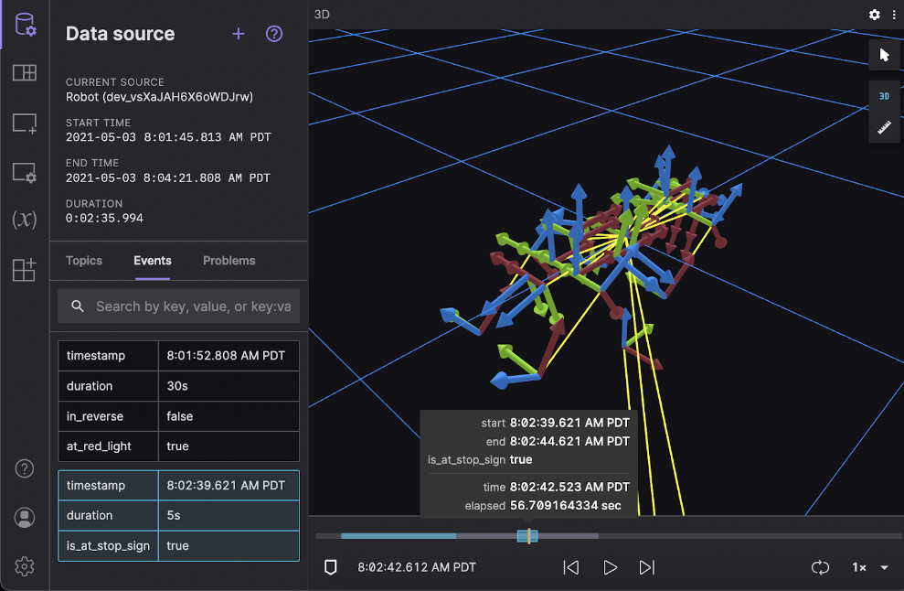

**CHAPTER 5: ROVER CONTROL**

For the Rover Control part of the project, we utilized the ArduRover firmware, specifically version 4.2.3, which was installed onto the Pixhawk 2.4.8 flight controller. The installation process involved connecting the Pixhawk to the computer using a USB cable. Then, we opened the Mission Planner Ground Control Station (GCS) and connected to the Pixhawk by selecting the appropriate port and baud rate displayed in the top right corner of the screen.

To install the ArduRover firmware, we navigated to the Setup window of the GCS, which is displayed in the top left corner. In the Setup window, the first option showed all the options for firmware installation. We clicked on the ArduRover firmware and followed the on-screen instructions to install the latest release.

To control the rover's movements, we used various commands in the Mission Planner GCS. For example, to initiate a manual mode for the rover, we used the command:

mode MANUAL

To switch to an autonomous mode, such as Auto mode, we used the command:

mode AUTO

To arm the rover and enable motor control, we used the command:

arm throttle

To set the rover's desired speed, we used the command:

speed_set 1.0

This command would set the desired speed to 1.0 m/s. Adjusting the value allowed us to control the rover's speed during autonomous missions.

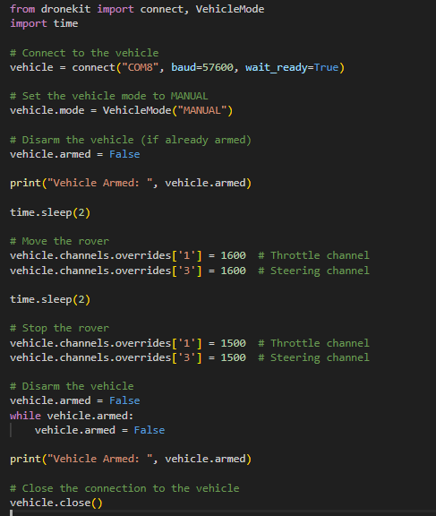In addition to the ArduRover firmware, we utilized the DroneKit library for communication and interaction with the rover. DroneKit provided a set of APIs and tools for developing custom scripts and commands to control the rover's behavior autonomously. With DroneKit, we could send high-level commands to the rover, monitor its status, and receive telemetry data.

Mission Planner served as the primary Ground Control Station (GCS) for the project. It provided a graphical user interface (GUI) for monitoring the rover's telemetry data, setting up mission parameters, and sending commands during mission operations. Mission Planner allowed us to visualize the rover's position on a map, monitor sensor data, and track the progress of the mission.

To establish communication between the ground station and the rover, we utilized MAVROS (MAVLink for ROS). MAVROS acted as a middleware, facilitating the communication between the Robot Operating System (ROS) and the MAVLink protocol. It provided ROS nodes with the ability to interact with the rover using MAVLink messages. Through MAVROS, we could send commands to control the rover's movements, receive telemetry data, and monitor its status.

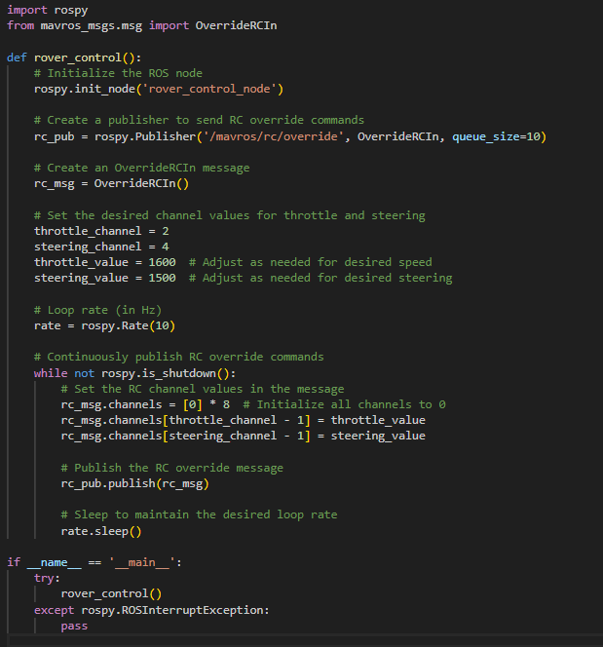

We also utilized MAVProxy as a flexible command-line tool and ground control station. MAVProxy served as an intermediary between the user and the rover, providing a command and control interface using the MAVLink protocol. It allowed us to send commands, receive telemetry data, and monitor the system status of the rover. MAVProxy could be customized through modules to add additional functionalities and integrate with other systems.

**CHAPTER 6: ROBOTIC ARM CONTROL**

To control the robotic arm, the first step is to create a URDF (Unified Robot Description Format) model of the arm in Blender. URDF is a widely used format for representing robotic systems in ROS. Blender provides powerful features for creating and visualizing 3D models, making it a suitable tool for designing the arm.

Once the URDF model of the robotic arm is created in Blender, it needs to be exported to MoveIt setup. MoveIt is a popular motion planning framework in ROS that provides capabilities for path planning, motion control, and collision checking.

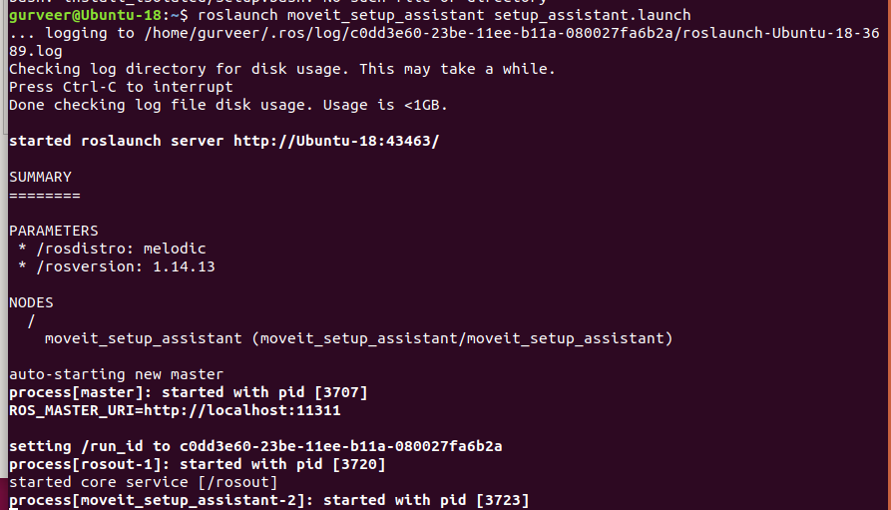In MoveIt, you can generate additional information such as the arm's kinematics, collisions, and other required configurations based on the URDF model. This information is crucial for performing various arm control operations.

The steps to make a package for the arm are as follows:

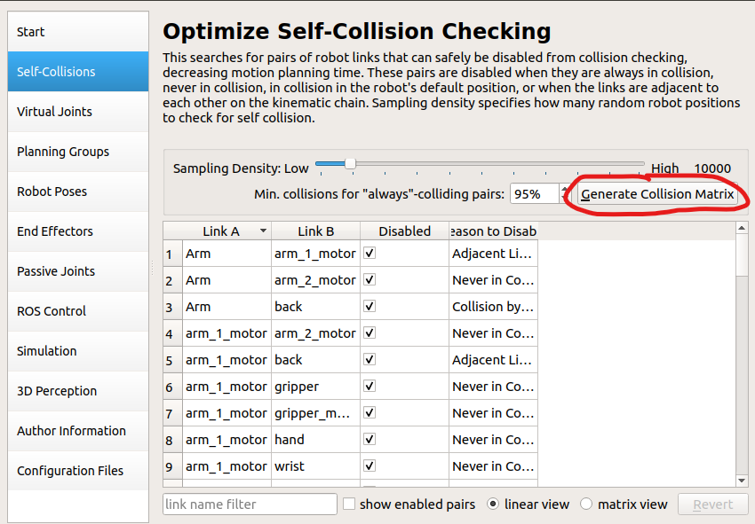

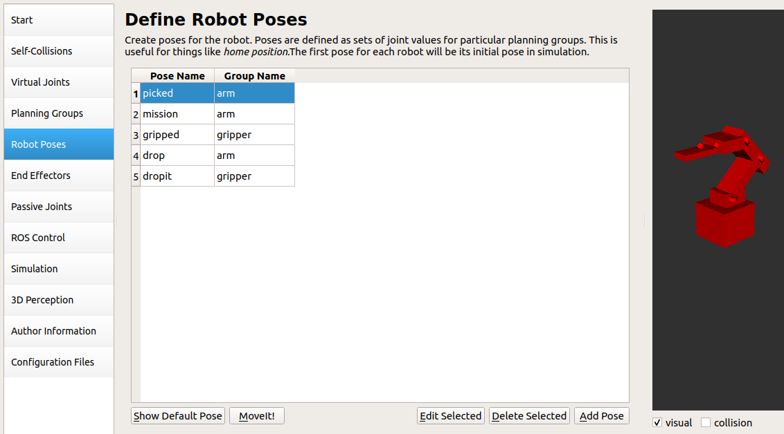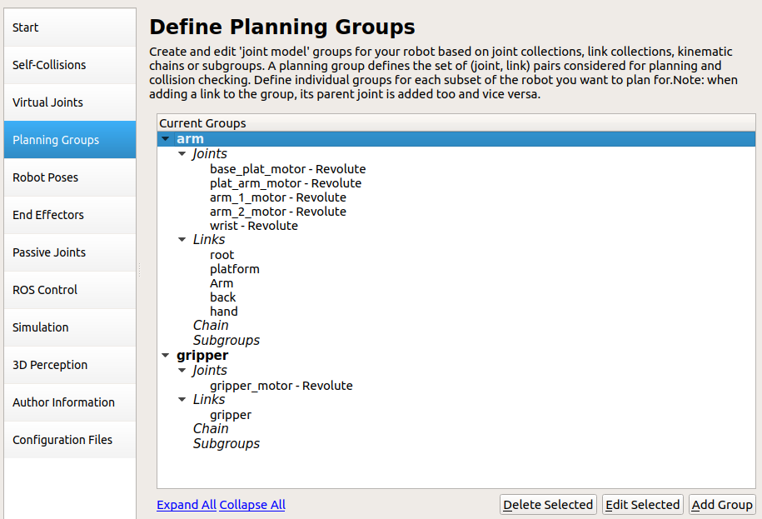select any appropriate IK solvers for the groups

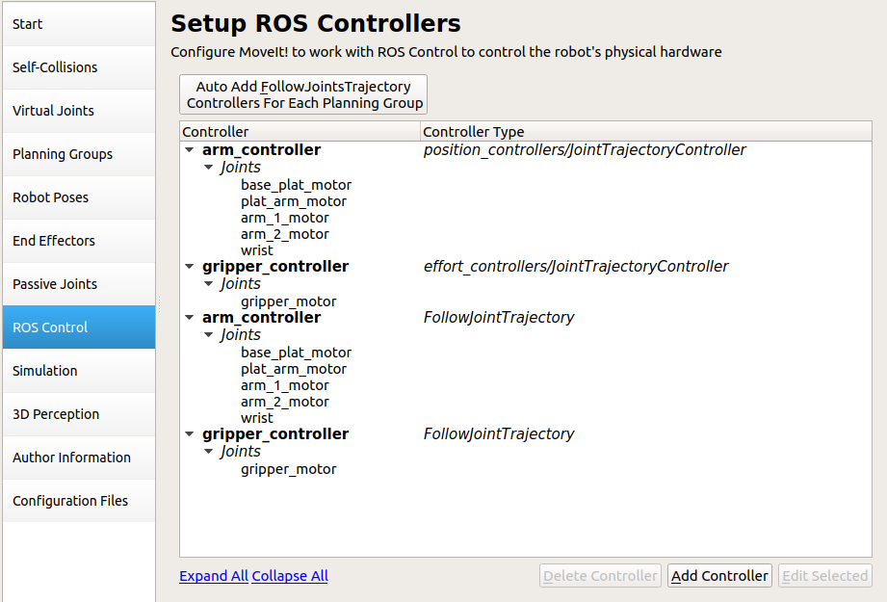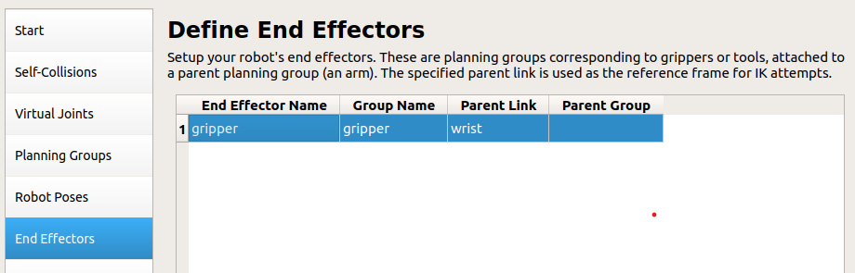

Finally, generate the package in configuration files.

After setting up MoveIt with the exported URDF model, you can leverage its functionalities to control the robotic arm. MoveIt provides APIs and interfaces for trajectory planning, inverse kinematics, and executing arm movements.

To control the physical hardware of the robotic arm, a PCA9685 ROS node is utilized. The PCA9685 is a popular PWM (Pulse Width Modulation) driver that enables precise control of servo motors, which are commonly used in robotic arms. The ROS node for the PCA9685 provides an interface to send control signals to the servo motors and adjust their positions.

The Robot Pose Publisher is a ROS node used for publishing the arm's joint positions. It takes the joint angle values generated by MoveIt and publishes them as joint states in the ROS system. This allows other nodes and components to access the arm's joint states and perform further actions based on the arm's current configuration.

By combining these components and tools, you can achieve control over the robotic arm. MoveIt provides motion planning capabilities, inverse kinematics, and collision detection, allowing you to plan and execute precise arm movements. The PCA9685 ROS node enables communication with the servo motors to control the arm's physical movement. The Robot Pose Publisher ensures that the arm's joint states are available in the ROS system, enabling other nodes to utilize this information for various purposes.

Overall, this integration of MoveIt, PCA9685 ROS node, and the Robot Pose Publisher enables the control and manipulation of the robotic arm, making it possible to perform tasks such as object manipulation, pick and place operations, or any other desired arm movements.

**CHAPTER 7: COMPUTER VISION**

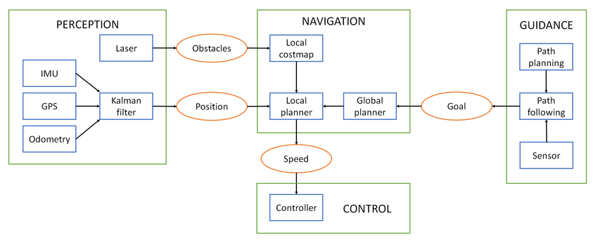

USB Camera for Object Detection:

The USB camera is mounted on the front of the rover and serves as the primary source for object detection. It captures a live video feed of the rover's surroundings. Jetson Inference, a deep learning package optimized for NVIDIA Jetson platforms, provides pre-trained object detection models. These models utilize convolutional neural networks (CNNs) to analyze the camera feed and identify objects in real-time. By leveraging the power of Jetson Nano, the rover can perform efficient and accurate object detection.

Aligning Rover with Detected Objects:

After objects are detected using the USB camera, the rover needs to align itself with the direction of the detected objects. The object detection algorithm provides information about the location and orientation of the objects in the camera frame. By analyzing this information, the rover can calculate the required movements to align itself with the desired object. This may involve adjusting the rover's position and orientation, such as turning or moving towards the object, to achieve proper alignment.

CSI Camera for Top View:

The CSI camera is attached to the gripper's motor and is positioned to capture a top-down view of the rover's surroundings. This camera provides a different perspective, allowing the rover to obtain a bird's-eye view of the detected object. By moving the gripper's motor, the rover can adjust the position and angle of the CSI camera to achieve the desired top-down view. This perspective is useful for precise navigation and manipulation tasks, enabling the rover to accurately perceive the object's location and make informed decisions.

Obstacle Avoidance using RPLidar and Cartographer:

To navigate its environment and avoid obstacles, the rover utilizes an RPLidar sensor. The RPLidar emits laser beams and measures the time it takes for the beams to bounce back, creating a 360-degree laser scan of the surrounding environment. This scan provides information about the presence and location of obstacles in the rover's path. Cartographer, a mapping and localization system in ROS, uses the laser scan data from the RPLidar to build a map of the environment and perform SLAM. By combining the mapping information with the rover's odometry data, Cartographer enables the rover to accurately localize itself within the map and navigate around obstacles while planning an optimal path towards the detected object. This ensures safe and efficient movement even in complex environments.

By integrating these components, the rover achieves advanced capabilities in computer vision, object detection, alignment, top-down view acquisition, and obstacle avoidance. This allows the rover to autonomously detect and locate objects, align itself with the desired object, obtain a comprehensive view of the object from different perspectives, and navigate through its environment while avoiding obstacles. The combination of computer vision, sensors, and mapping algorithms enables the rover to perform complex tasks, making it capable of intelligent and autonomous exploration and interaction with its surroundings.

**CHAPTER 8 : ROS TOPICS AND THEIR CONNECTIONS**

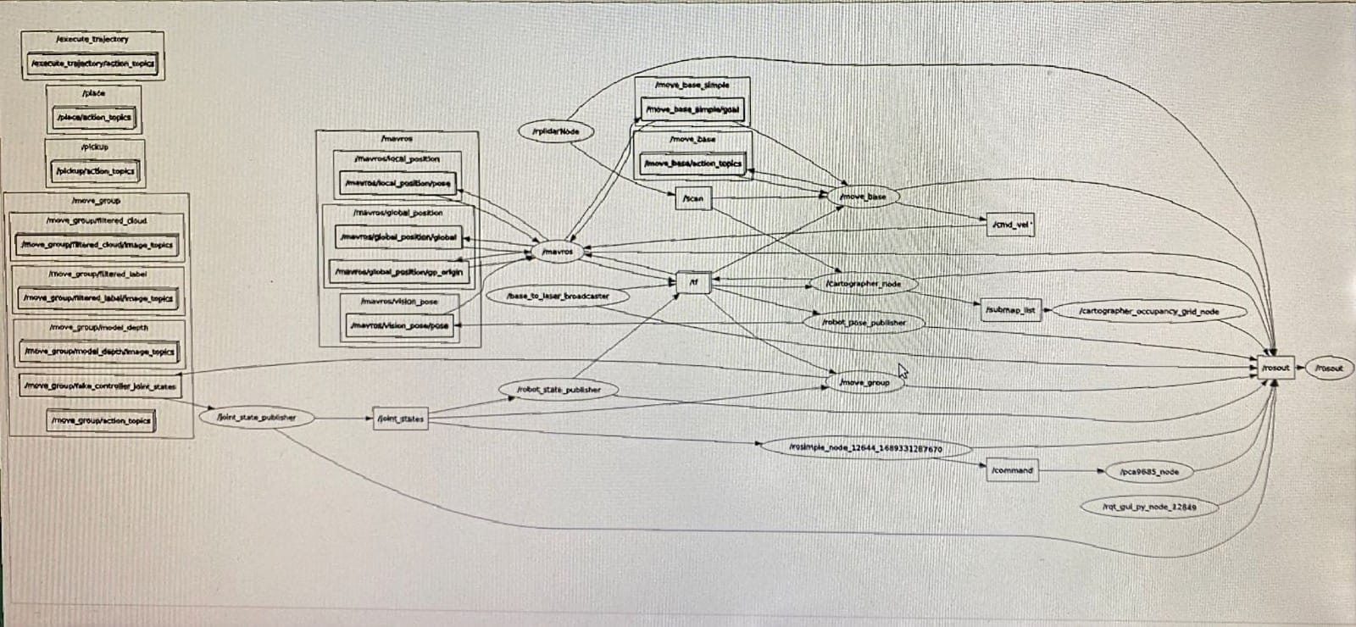

Nodes and Topics are fundamental components in the ROS (Robot Operating System) framework that enable communication and coordination between different parts of a robotic system. Here's an explanation of the mentioned Nodes and Topics:

1. /execute_trajectory:

The /execute_trajectory topic is typically associated with a node responsible for executing predefined trajectories or motion plans. It allows the system to receive trajectory commands and carry out the specified motion or sequence of actions.

2. /place:

The /place topic is typically associated with a node responsible for placing or releasing an object. It provides a communication interface to send commands or instructions related to the placement of objects by the robotic system.

3. /pickup:

The /pickup topic is typically associated with a node responsible for picking up or grasping an object. It provides a communication interface to send commands or instructions related to the gripping or manipulation of objects by the robotic system.

4. /move_group:

The /move_group topic is often associated with a node that manages the motion planning and control of a robotic arm or group of joints. It allows for high-level control commands, such as specifying desired positions or trajectories, and interfaces with other components to execute the planned motions.

5. /mavros:

The /mavros topic is associated with the MAVROS node, which provides a communication bridge between ROS and MAVLink-enabled autopilots, typically used in unmanned aerial vehicles (UAVs). It facilitates communication and control between ROS nodes and the flight controller, enabling integration and interaction with the UAV system.

6. /joint_state_publisher:

The /joint_state_publisher topic is typically associated with a node responsible for publishing the state of joints in a robotic system. It provides information about the current positions, velocities, and efforts of each joint, allowing other components to access and utilize this data.

7. /joint_states:

The /joint_states topic is used for publishing the current states of joints in a robotic system. It provides a standardized format for sharing joint state information across different nodes and components within the system.

8. /rplidarNode:

The /rplidarNode topic is associated with a node that interfaces with an RPLidar sensor. It receives laser scan data from the sensor and publishes it on this topic, allowing other nodes to access and process the information for tasks such as mapping, obstacle detection, or localization.

9. /base_to_laser_broadcaster:

The /base_to_laser_broadcaster topic is often associated with a node responsible for transforming the coordinate frames between the robot's base and a laser sensor mounted on it. It publishes the transformation information, allowing other nodes to accurately interpret the laser scan data in the robot's coordinate frame.

10. /robot_state_publisher:

The /robot_state_publisher topic is associated with a node that publishes the state of the robot's kinematic model. It broadcasts the transform information between different links or joints of the robot, allowing other nodes to understand the robot's pose and configuration in the global coordinate system.

11. /move_base_simple:

The /move_base_simple topic provides a simple interface for commanding the robot's movement to a specified goal position. It allows users or higher-level systems to send goal poses in a straightforward format, simplifying the process of issuing navigation commands.

12. /move_base:

The /move_base topic is often associated with a node responsible for high-level navigation and path planning. It receives goal poses from other nodes and generates a trajectory or path for the robot to follow, considering the environment and any obstacles.

13. /tf:

The /tf topic is a fundamental topic in ROS that handles the transformation data between different coordinate frames in a robot system. It provides a way to broadcast and subscribe to transformation information, enabling accurate localization, mapping, and coordination between various components.

14. /cartographer_node:

The /cartographer_node topic is associated with a node that implements the Cartographer system for simultaneous localization and mapping (SLAM). It receives sensor data, such as laser scans and odometry, and generates a map of the environment while estimating the robot's pose and trajectory.

15. /robot_pose_publisher:

The /robot_pose_publisher topic is often associated with a node responsible for publishing the pose or position information of the robot in a global coordinate frame. It provides a common reference for other nodes to understand the robot's position and orientation in the world.

16. /cmd_vel:

The /cmd_vel topic is commonly associated with a node responsible for receiving velocity commands for controlling the robot's movement. It allows users or other components to send linear and angular velocity commands to drive the robot in a desired direction.

17. /command:

The /command topic can be associated with various nodes depending on the specific application. It provides a communication interface for sending specific commands or instructions to control different aspects of the robot's behavior or functionalities.

These Nodes and Topics play essential roles in facilitating communication, coordination, and control within a robotic system, allowing different components and nodes to interact effectively and accomplish complex tasks.

**CONCLUSION**

In conclusion, the development and implementation of the prototype planetary rover with a robotic arm using ROS has been successfully achieved. Throughout the project, various hardware and software components were integrated to enable object pick and drop operations, autonomous navigation, and robotic arm control.

The use of ROS as the underlying framework provided a robust and flexible platform for communication, control, and coordination among the different system components. The integration of the Nvidia Jetson Nano, along with its powerful computational capabilities, allowed for the execution of SLAM algorithms and autonomous decision-making processes.

The successful utilization of the robotic arm, with its range of motion and payload capacity, demonstrated the system's capability to manipulate objects in the planetary environment. The integration of external sensors such as IMU, GPS, Lidar, and cameras enabled accurate perception of the rover's surroundings, facilitating path planning and obstacle avoidance.

Furthermore, computer vision techniques, including the use of USB and CSI cameras, allowed for object detection, alignment, and top-down view acquisition. The implementation of Jetson Inference provided efficient object detection capabilities, while the RPLidar and Cartographer combination facilitated obstacle detection and mapping.

The project's results demonstrated the feasibility and effectiveness of the developed system for planetary exploration scenarios. The rover successfully executed object pick and drop operations, navigated autonomously using SLAM-based algorithms, and demonstrated robustness in perceiving and avoiding obstacles.

In future enhancements, further improvements can be made to enhance the system's capabilities. This may include refining the object detection algorithms, optimizing path planning algorithms, integrating additional sensors for improved perception, and enhancing the control algorithms for more precise and efficient manipulation.

Overall, the successful development of the prototype planetary rover with a robotic arm using ROS opens up possibilities for further advancements in the field of planetary exploration and robotics. The project showcases the potential of integrating advanced technologies and demonstrates the importance of a comprehensive system design and integration approach for achieving successful outcomes in complex robotics projects.

**FUTURE ENHANCEMENTS**

Future enhancements for the prototype planetary rover with a robotic arm using ROS can focus on several areas to further improve its capabilities and expand its functionality. Some potential areas for enhancement include:

1. Enhanced Object Manipulation: Improve the robotic arm's dexterity and gripping capabilities to handle objects of various shapes, sizes, and weights. This can involve designing and integrating specialized grippers or end effectors for specific tasks and exploring advanced grasping and manipulation techniques.

2. Autonomous Decision-Making: Develop more sophisticated algorithms for autonomous decision-making and task planning. This can involve incorporating higher-level reasoning capabilities, such as task prioritization, task sequencing, and task optimization, to enable the rover to autonomously plan and execute complex missions in dynamic environments.

3. Intelligent Perception: Enhance the perception capabilities of the rover by integrating advanced computer vision techniques. This can include implementing object recognition and tracking algorithms to improve object detection and alignment accuracy. Additionally, explore the use of deep learning techniques to enhance the rover's understanding and interpretation of the surrounding environment.

4. Robust Localization and Mapping: Improve the rover's localization and mapping capabilities by incorporating state-of-the-art SLAM algorithms and sensor fusion techniques. This can involve utilizing additional sensors, such as stereo cameras or depth sensors, to enhance the accuracy and robustness of the mapping and localization process, especially in challenging or unstructured environments.

5. Multi-Robot Collaboration: Investigate the feasibility of multi-robot collaboration and coordination. This can involve developing communication protocols and coordination algorithms to enable multiple rovers to work together on complex tasks, such as cooperative object manipulation or distributed exploration.

6. Long-Distance Communication: Enhance the rover's communication capabilities to extend its range of operation. This can involve exploring long-range communication technologies, such as satellite communication or mesh networks, to enable remote control and monitoring of the rover over long distances.

7. Integration of Environmental Sensors: Integrate additional environmental sensors, such as temperature sensors or atmospheric sensors, to gather more comprehensive data about the planetary environment. This data can be used for environmental monitoring, analysis, and further scientific research.

8. User Interface and Interaction: Develop a user-friendly interface and interaction mechanisms to enable easy control and monitoring of the rover's operations. This can include the development of a graphical user interface (GUI) or a web-based control panel that provides real-time feedback, mission planning capabilities, and data visualization.

9. Energy Efficiency: Explore ways to improve the energy efficiency of the rover system. This can involve implementing power management strategies, optimizing the usage of sensors and actuators, and incorporating energy harvesting techniques to extend the operational time and reduce reliance on external power sources.

10. Terrain Adaptability: Enhance the rover's ability to navigate and operate in diverse and challenging terrains. This can include designing and integrating mechanisms for terrain adaptation, such as adjustable suspension or variable traction systems, to improve mobility and stability on uneven or rough surfaces.

11. Redundancy and Fault Tolerance: Implement redundancy mechanisms and fault-tolerant features to ensure the system's robustness and reliability. This can involve incorporating backup systems for critical components, developing error detection and recovery algorithms, and integrating self-diagnostic capabilities to identify and mitigate failures in real-time.

12. Human-Robot Interaction: Explore methods to enable efficient and intuitive human-robot interaction. This can involve developing natural language processing algorithms for voice commands, integrating gesture recognition capabilities for intuitive control, and designing user-friendly interfaces that allow operators to easily monitor and intervene in rover operations when necessary.

13. Swappable Payloads: Design the rover system to support swappable payloads, allowing for flexibility in mission-specific tasks. This can include modular designs that enable the attachment and detachment of different sensors, tools, or instruments to adapt to varying exploration or research objectives.

14. Enhanced Autonomy: Research and implement advanced autonomy features, such as adaptive path planning, obstacle avoidance, and decision-making algorithms that can learn and adapt to changing environments. This would enable the rover to autonomously navigate and accomplish tasks in real-time without continuous human intervention.

15. Robust Communication and Data Transfer: Improve the communication and data transfer capabilities of the rover system. This can involve exploring wireless communication protocols, optimizing data compression techniques, and implementing reliable data transmission protocols to ensure efficient and secure exchange of information between the rover and control stations.

16. System Integration and Testing: Conduct comprehensive system integration and testing to validate the overall performance, reliability, and safety of the rover system. This includes rigorous testing in simulated environments, as well as field testing under relevant conditions to identify and address any potential issues or limitations.

By addressing these future enhancements, the prototype planetary rover with a robotic arm can evolve into a more capable and versatile system, ready to tackle complex tasks in planetary exploration, research, and other applications. The continuous development and improvement of such robotic systems will contribute to advancements in space exploration, scientific research, and technological innovation.

**REFERENCES**

1. ArduRover:

- ArduPilot Official Website: https://ardupilot.org/rover/

2. DroneKit:

- DroneKit Python Documentation: https://dronekit-python.readthedocs.io/

- DroneKit GitHub Repository: https://github.com/dronekit/dronekit-python

3. Mission Planner:

- Mission Planner Documentation: https://ardupilot.org/planner/docs/mission-planner-overview.html

- Mission Planner GitHub Repository: https://github.com/ArduPilot/MissionPlanner

4. MAVROS:

- MAVROS GitHub Repository: https://github.com/mavlink/mavros

- MAVROS ROS Wiki: http://wiki.ros.org/mavros

5. MAVProxy:

- MAVProxy GitHub Repository: https://github.com/ArduPilot/MAVProxy

6. Blender:

- Blender Official Website: https://www.blender.org/

- Blender Documentation: https://docs.blender.org/manual/en/latest/

7. Jetson Nano Developer Kit Image:

- NVIDIA Jetson Nano Developer Kit Documentation: https://developer.nvidia.com/embedded/jetson-nano-developer-kit

8. Ubuntu 18.04:

- Ubuntu Documentation: https://help.ubuntu.com/18.04/

9. ROS Melodic:

- ROS Melodic Documentation: http://wiki.ros.org/melodic

10. MAVLink:

- MAVLink GitHub Repository: https://github.com/mavlink/mavlink

11. MoveIt:

- MoveIt Official Website: https://moveit.ros.org/

- MoveIt GitHub Repository: https://github.com/ros-planning/moveit

12. RViz:

- RViz ROS Wiki: http://wiki.ros.org/rviz

13. PCA9685 ROS Node:

- PCA9685 ROS Node GitHub Repository: https://github.com/dheera/ros-pwm-pca9685

14. Robot Pose Publisher:

- Robot Pose Publisher ROS Wiki: http://wiki.ros.org/robot_pose_publisher

15. SLAMTECH RPLidar ROS Node:

- RPLidar ROS GitHub Repository: https://github.com/Slamtec/rplidar_ros

16. Cartographer:

- Cartographer GitHub Repository: https://github.com/cartographer-project/cartographer

17. Move Base:

- Move Base ROS Wiki: http://wiki.ros.org/move_base

18. TF:

- TF ROS Wiki: http://wiki.ros.org/tf

19. Jetson Inference:

- Jetson Inference GitHub Repository: https://github.com/dusty-nv/jetson-inference

20. XRDP:

- XRDP GitHub Repository: <https://github.com/neutrinolabs/xrdp>

**APPENDIX**

**#Rover Control**

#!/usr/bin/env python2

# ROS

import rospy

from mavros_msgs.msg import OverrideRCIn

from mavros_msgs.srv import SetMode

from mavros_msgs.srv import CommandBool

from mavros_msgs.srv import CommandTOL

# System

import time

rospy.init_node('rosimple_node', anonymous = True)

# Set Mode

print("SET MODE")

rospy.wait_for_service('/mavros/set_mode')

try:

modeService = rospy.ServiceProxy('/mavros/set_mode', SetMode)

modeResponse = modeService(0, 'GUIDED')

rospy.loginfo(modeResponse)

except rospy.ServiceException as e:

print("Service call failed: %s" %e)

# Arm

print("ARM")

rospy.wait_for_service('/mavros/cmd/arming')

try:

armService = rospy.ServiceProxy('/mavros/cmd/arming', CommandBool)

armResponse = armService(True)

rospy.loginfo(armResponse)

except rospy.ServiceException as e:

print("Service call failed: %s" %e)

time.sleep(3)

# TAKEOFF

print("TAKEOFF")

x=0

while not rospy.is_shutdown() and x==0:

print("PRESS 1 TO SHUTDOWN:\n")

x=int(input())

print("DISARM")

rospy.wait_for_service('/mavros/cmd/arming')

try:

armService = rospy.ServiceProxy('/mavros/cmd/arming', CommandBool)

armService(False)

except rospy.ServiceException as e:

print("Service call failed: %s" %e)

**#Robotic Arm Control**

#!/usr/bin/env python2

# ROS

import rospy

from std_msgs.msg import Int32MultiArray, MultiArrayLayout, Int32

from sensor_msgs.msg import JointState

# System

import time

l=[]

old=[2000,1200,1120,1120,2700,2300]

pos = [[2,5250,2000,8500], [3,5325, 1200,7500], [0,0,1120,8200], [5,1235,1120,8300], [1,0,2700,6000], [4,2300,2300,4400]]

rospy.init_node('rosimple_node', anonymous = True)

pub = rospy.Publisher('/command', Int32MultiArray, queue_size = 10)

def val(rad,no,main, minv, maxv):

if no==4:

x = rad/1.57

elif no==5:

x = rad/1.09706

else:

x = rad/3.142

return int(main+(maxv-minv)*x)

def joint_states_callback(dat):

global l

global old

l=dat.position

if old != l:

pwm=[ val(l[2],0,5173,2000,8346),val(l[4],1,5325, 1200,7500), val(l[0],2,0,1120,8200), val(l[1],3,2907,1200,8300), val(l[5],4,0,2700,6000), val(l[3],5,4700,4700,6300), -1,-1,-1,-1,-1,-1,-1,-1,-1,-1 ]

msg=Int32MultiArray(data=pwm, layout=MultiArrayLayout())

pub.publish(msg)

rospy.loginfo(msg)

old = l

rospy.Subscriber('/joint_states', JointState, joint_states_callback)

r = rospy.Rate(1) #10hz

time.sleep(1)

while 1:

x=int(input("Continue (1 for yes, 0 for no): "))

if x == 0:

break

**# Computer Vision**

**#GStreamer**

import gi

gi.require_version('Gst','1.0')

gi.require_version('GstVideo','1.0')

gi.require_version('GstRtspServer','1.0')

from gi.repository import GObject, Gst, GstVideo, GstRtspServer

Gst.init(None)

mainloop = GObject.MainLoop()

server = GstRtspServer.RTSPServer()

mounts = server.get_mount_points()

factory1 = GstRtspServer.RTSPMediaFactory()

factory2 = GstRtspServer.RTSPMediaFactory()

factory1.set_launch('( gst-launch-1.0 -v nvarguscamerasrc sensor-id=0 ! video/x-raw(memory:NVMM),format=NV12,width=1280,height=720,framerate=30/1 ! nvvidconv ! nvv4l2h264enc insert-sps-pps=1 idrinterval=30 insert-vui=1 ! rtph264pay name=pay0 )')

factory2.set_launch('( v4l2src device=/dev/video1 ! video/x-raw,format=YUY2,width=640,height=480,framerate=30/1 ! nvvidconv ! nvv4l2h264enc insert-sps-pps=1 idrinterval=30 insert-vui=1 ! rtph264pay name=pay0 )')

mounts.add_factory("/cam1", factory1)

mounts.add_factory("/cam2", factory2)

server.attach(None)

print "stream ready at rtsp://127.0.0.1:8554/cam1 & cam2"

mainloop.run()

**#Autonomous Navigation**

import cv2

import sys

import copy

import jetson_inference

import jetson_utils

import rospy

from mavros_msgs.msg import OverrideRCIn

from mavros_msgs.srv import SetMode

from mavros_msgs.srv import CommandBool

from mavros_msgs.srv import CommandTOL

from std_msgs.msg import Int8

import moveit_commander

import moveit_msgs.msg

from moveit_msgs.msg import Constraints, OrientationConstraint

import geometry_msgs.msg

from std_msgs.msg import String, Int32MultiArray, MultiArrayLayout, Int32

from sensor_msgs.msg import JointState

from moveit_commander.conversions import pose_to_list

from tf.transformations import quaternion_from_euler, euler_from_quaternion

moveit_commander.roscpp_initialize(sys.argv)

rospy.init_node('rosimple_node', anonymous = True, disable_signals=True)

print("SET MODE")

rospy.wait_for_service('/mavros/set_mode')

try:

modeService = rospy.ServiceProxy('/mavros/set_mode', SetMode)

modeResponse = modeService(0, 'MANUAL')

rospy.loginfo(modeResponse)

except rospy.ServiceException as e:

print("Service call failed: %s" %e)

# Arm

print("ARM")

rospy.wait_for_service('/mavros/cmd/arming')

try:

armService = rospy.ServiceProxy('/mavros/cmd/arming', CommandBool)

armResponse = armService(True)

rospy.loginfo(armResponse)

except rospy.ServiceException as e:

print("Service call failed: %s" %e)

#time.sleep(3)

throttle_left_channel = 0 # throttle right movement

throttle_right_channel = 2 # throttle right movement

pub = rospy.Publisher('mavros/rc/override', OverrideRCIn, queue_size = 10)

msg = OverrideRCIn()

camera = jetson_utils.videoSource("/dev/video1") # '/dev/video0' for V4L2

camera2 = jetson_utils.videoSource("csi://0")

#display = jetson_utils.videoOutput("display://0")

net = jetson_inference.detectNet("ssd-mobilenet-v2")

while True:

x2,y2=0,0

img = camera.Capture()

if img is None: # capture timeout

continue

detections = net.Detect(img)

frame = jetson_utils.cudaToNumpy(img)

width = 640 #1280/2

height = 360 #720/2

cv2.line(frame, (width, height*2), (width, 0), (0, 255, 0), thickness=2)

cv2.line(frame, (0, height), (width*2, height), (0, 255, 0), thickness=2)

cv2.circle(frame,(width,height),4,(0,255,255),-1)

if len(detections)>0: #Length of list of objects detected

obj=detections[0] #First object in list

l=int(obj.Left)

r=int(obj.Right)

b=int(obj.Bottom)

t=int(obj.Top)

x2=l+(r-l)/2

y2=b+(t-b)/2

cv2.rectangle(frame, (int(l),int(b)), (int(r),int(t)), (0, 0, 255), 2)

cv2.circle(frame,(x2,y2),4,(0,255,255),-1)

# Calculating distance w.r.t center of screen (Origin: 640,360)

dist1 = (x2-width)

#dist2 = (y2-height)

if (abs(dist1)<5):

msg.channels[throttle_left_channel] = 1500

msg.channels[throttle_right_channel] = 1500

pub.publish(msg)

rospy.loginfo(msg)

break

#print("DISARM")

#rospy.wait_for_service('/mavros/cmd/arming')

#try:

# armService = rospy.ServiceProxy('/mavros/cmd/arming', CommandBool)

# armService(False)

#except rospy.ServiceException as e:

# print("Service call failed: %s" %e)

#exit(0)

#throttle right

elif dist1>0:

# Low_Lim=1100__Back, Stop=1500, Up_Lim=1900__Forward

msg.channels[throttle_left_channel] = 1700

msg.channels[throttle_right_channel] = 1500

pub.publish(msg)

rospy.loginfo(msg)

#throttle left

elif dist1<0:

msg.channels[throttle_left_channel] = 1300

msg.channels[throttle_right_channel] = 1500

pub.publish(msg)

rospy.loginfo(msg)

else:

msg.channels[throttle_left_channel] = 1500

msg.channels[throttle_right_channel] = 1500

pub.publish(msg)

rospy.loginfo(msg)

#print(msg,"\n\n\n\n\n\n\n\n\n\n\n\n")

#cv2.imshow("OUTPUT", frame)

key = cv2.waitKey(1)

#display.Render(img)

#display.SetStatus("Object Detection | Network {:.0f} FPS".format(net.GetNetworkFPS()))

if key == ord('q'):

break

cv2.destroyAllWindows()

while True:

x2,y2,f=0,0,0

img = camera2.Capture()

if img is None: # capture timeout

continue

detections = net.Detect(img)

frame = jetson_utils.cudaToNumpy(img)

width = 640 #1280/2

height = 360 #720/2

cv2.line(frame, (width, height*2), (width, 0), (0, 255, 0), thickness=2)

cv2.line(frame, (0, height), (width*2, height), (0, 255, 0), thickness=2)

cv2.circle(frame,(width,height),4,(0,255,255),-1)

if len(detections)>0: #Length of list of objects detected

f = 1

obj=detections[0] #First object in list

l=int(obj.Left)

r=int(obj.Right)

b=int(obj.Bottom)

t=int(obj.Top)

x2=l+(r-l)/2

y2=b+(t-b)/2

cv2.rectangle(frame, (int(l),int(b)), (int(r),int(t)), (0, 0, 255), 2)

cv2.circle(frame,(x2,y2),4,(0,255,255),-1)

# Calculating distance w.r.t center of screen (Origin: 640,360)

#dist1 = (x2-width)

dist2 = (y2-height)

if (abs(dist2)<5):

msg.channels[throttle_left_channel] = 1500

msg.channels[throttle_right_channel] = 1500

pub.publish(msg)

rospy.loginfo(msg)

break

print("DISARM")

rospy.wait_for_service('/mavros/cmd/arming')

try:

armService = rospy.ServiceProxy('/mavros/cmd/arming', CommandBool)

armService(False)

except rospy.ServiceException as e:

print("Service call failed: %s" %e)

exit(0)

#throttle right

elif dist2>0:

# Low_Lim=1100__Back, Stop=1500, Up_Lim=1900__Forward

msg.channels[throttle_left_channel] = 1500

msg.channels[throttle_right_channel] = 1375

pub.publish(msg)

rospy.loginfo(msg)

#throttle left

elif dist2<0:

msg.channels[throttle_left_channel] = 1500

msg.channels[throttle_right_channel] = 1625

pub.publish(msg)

rospy.loginfo(msg)

elif f == 0:

msg.channels[throttle_left_channel] = 1500

msg.channels[throttle_right_channel] = 1625

pub.publish(msg)

rospy.loginfo(msg)

else:

msg.channels[throttle_left_channel] = 1500

msg.channels[throttle_right_channel] = 1500

pub.publish(msg)

rospy.loginfo(msg)

#print(msg,"\n\n\n\n\n\n\n\n\n\n\n\n")

#cv2.imshow("OUTPUT", frame)

key = cv2.waitKey(1)

#display.Render(img)

#display.SetStatus("Object Detection | Network {:.0f} FPS".format(net.GetNetworkFPS()))

if key == ord('q'):

break

cv2.destroyAllWindows()

#arm

pub = rospy.Publisher('/command', Int32MultiArray, queue_size = 10)

robot = moveit_commander.RobotCommander()

scene = moveit_commander. PlanningSceneInterface()

group_name= "arm"

move_group = moveit_commander.MoveGroupCommander(group_name)

move_groupg = moveit_commander.MoveGroupCommander("gripper")

move_group.set_planning_time(40)

current_pose = move_group.get_current_pose().pose

move_groupg.set_named_target("dropit")

plan1 = move_groupg.plan()

move_groupg.execute(plan1, wait=True)

# go to goal

pose_goal = geometry_msgs.msg.Pose()

pose_goal.orientation = current_pose.orientation

previous = pose_goal.orientation

pose_goal.position.x = current_pose.position.x

pose_goal.position.y = current_pose.position.y

pose_goal.position.z = current_pose.position.z - 2.5

upright_constraints = Constraints()

upright_constraints.name = "upright"

orientation_constraint = OrientationConstraint()

pose = move_group.get_current_pose()

orientation_constraint.header.frame_id = pose.header.frame_id

orientation_constraint.link_name = move_group.get_end_effector_link()

orientation_constraint.orientation.x = current_pose.orientation.x

orientation_constraint.orientation.w = current_pose.orientation.w

orientation_constraint.orientation.y = current_pose.orientation.y

orientation_constraint.orientation.z = current_pose.orientation.z

orientation_constraint.absolute_x_axis_tolerance = 0.6

orientation_constraint.absolute_y_axis_tolerance = 0.4

orientation_constraint.absolute_z_axis_tolerance = 0.4

orientation_constraint.weight = 1.0

upright_constraints.orientation_constraints.append(orientation_constraint)

move_group.set_path_constraints(upright_constraints)

move_group.set_pose_target(pose_goal)

move_group.set_joint_value_target(pose_goal, move_group.get_end_effector_link())

move_group.go(wait=True)

move_group.stop()

move_group.clear_pose_targets()

# gripper close

move_groupg.set_named_target("picked")

plan1 = move_groupg.plan()

move_groupg.execute(plan1, wait=True)

# go to start

move_group.set_named_target("mission")

plan1 = move_group.plan()

move_group.execute(plan1, wait=True)

#time.sleep(2)

# gripper open

move_groupg.set_named_target("dropit")

plan1 = move_groupg.plan()

move_groupg.execute(plan1, wait=True)

#move_group.close()